

NBCC Pharmacy Sequence Diagrams  
2025 Programmer Analyst Team  
March 17, 2025

CONTENTS

US1 4

USER SIGNUP SSD 4

US2 5

DELETE USER SSD 5

US3 6

USER LOGIN SSD 6

RESET PASSWORD SSD 7

US4 8

CREATE ORDER SSD 8

US5 9

IMAGE UPLOAD ON ADD ORDER PAGE 9

IMAGE UPLOAD ON AMEND ORDER PAGE 10

IMAGE UPLOAD ON VERIFICATION PAGE 11

US7 12

VERIFY ORDER SSD 12

US8 13

AMEND ORDER 13

US9 14

PRINT DISPENSING LABEL SSD 14

US10 15

RE-PRINT DISPENSING LABEL SSD 15

US11 16

INACTIVITY SSD 16

US12 17

VIEW ORDERS 17

ORDERS TO VERIFY 18

US13 19

ADD DRUG 19

US14 20

VIEW DRUGS 20

US15 21

DELETE DRUG(S) 21

US16 22

EDIT DRUG 22

US17 23

ADD PHYSICIAN 23

US18 24

VIEW PHYSICIANS 24

US19 25

DELETE PHYSICIAN(S) 25

US20 26

EDIT PHYSICIAN 26

US21 27

ADD PATIENT 27

US22 28

VIEW PATIENTS 28

US23 29

DELETE PATIENT(S) 29

US24 30

EDIT PATIENT 30

# US1

## USER SIGNUP SSD

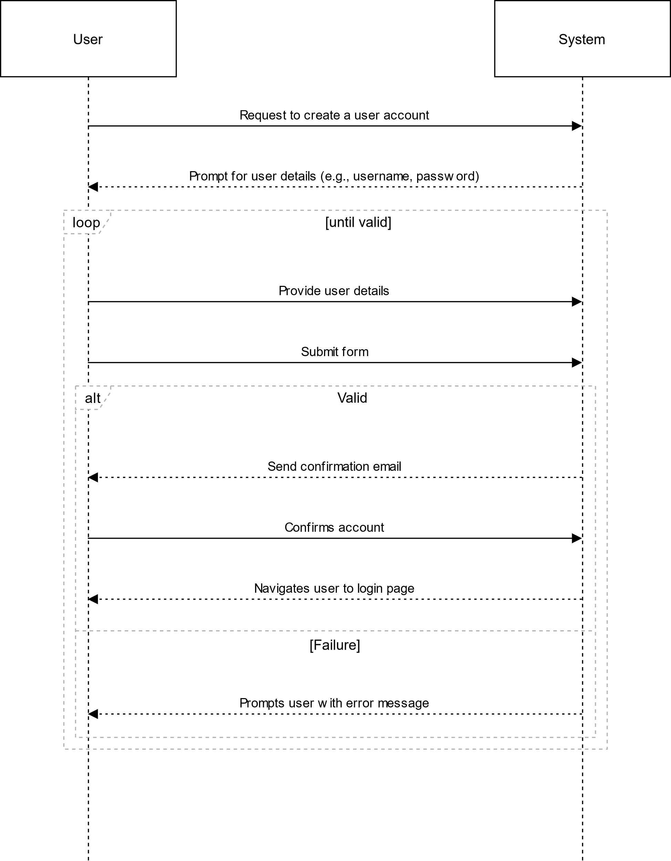

# US2

## DELETE USER SSD

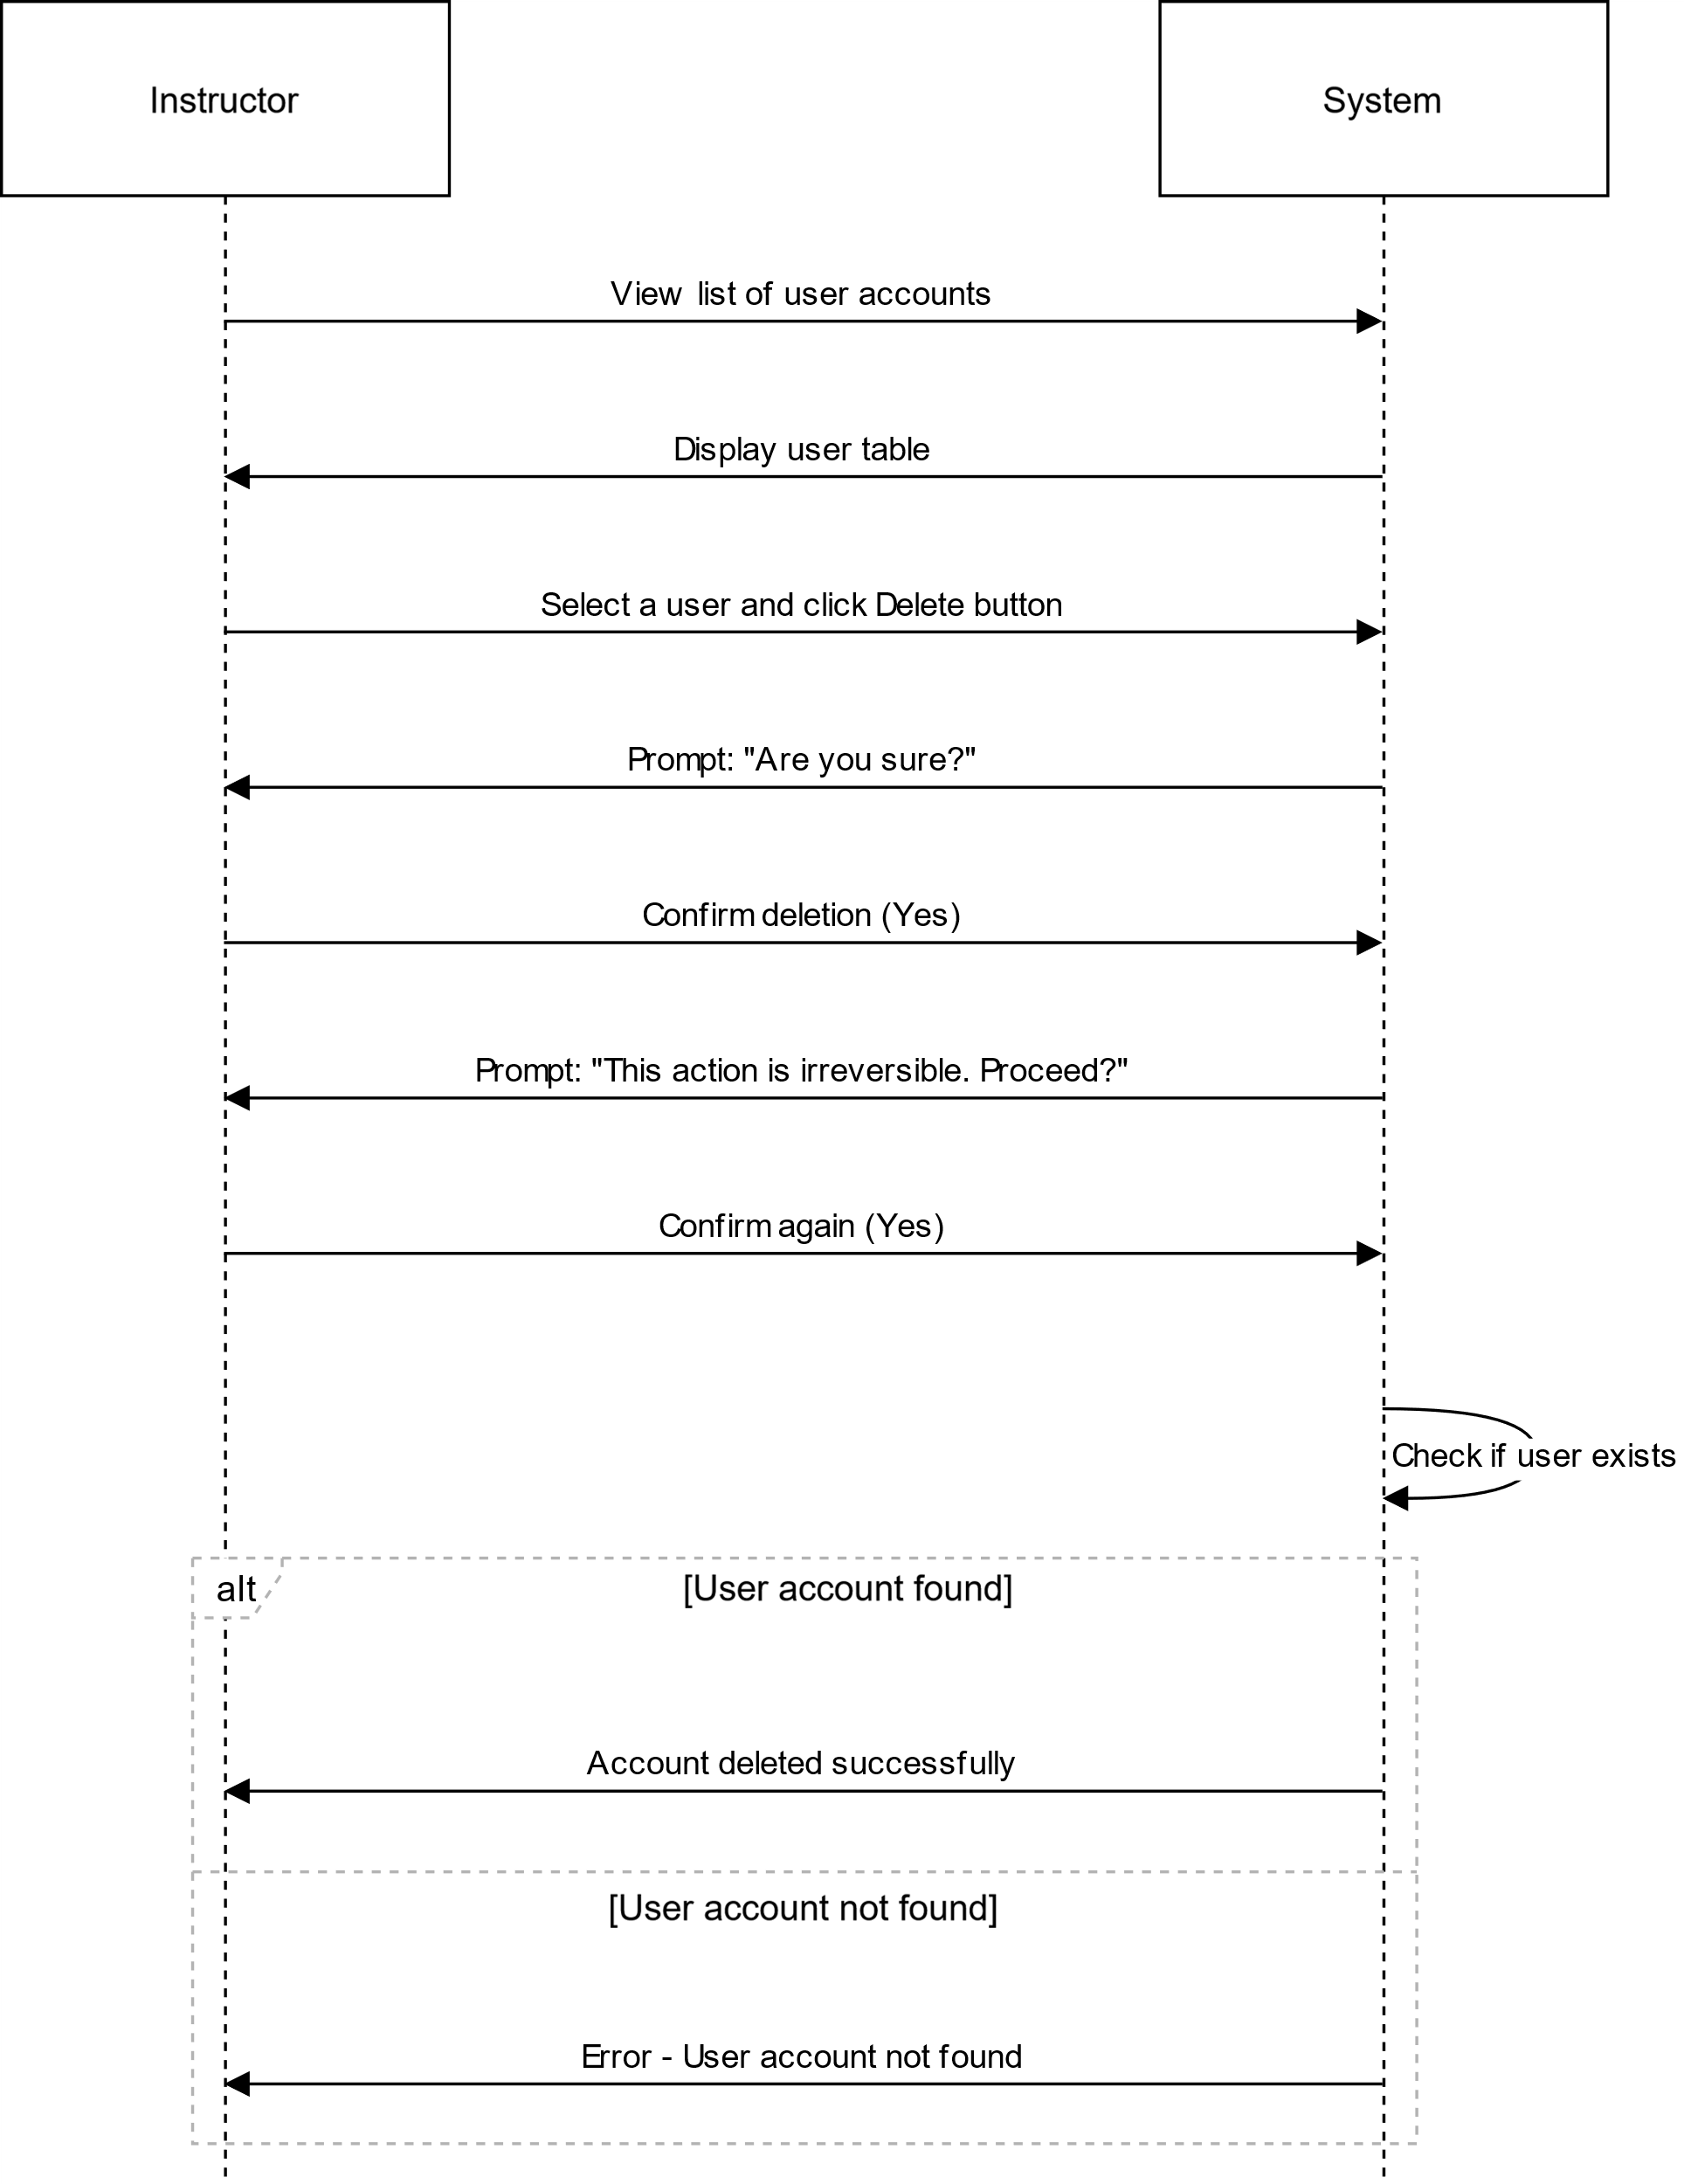

# US3

## USER LOGIN SSD

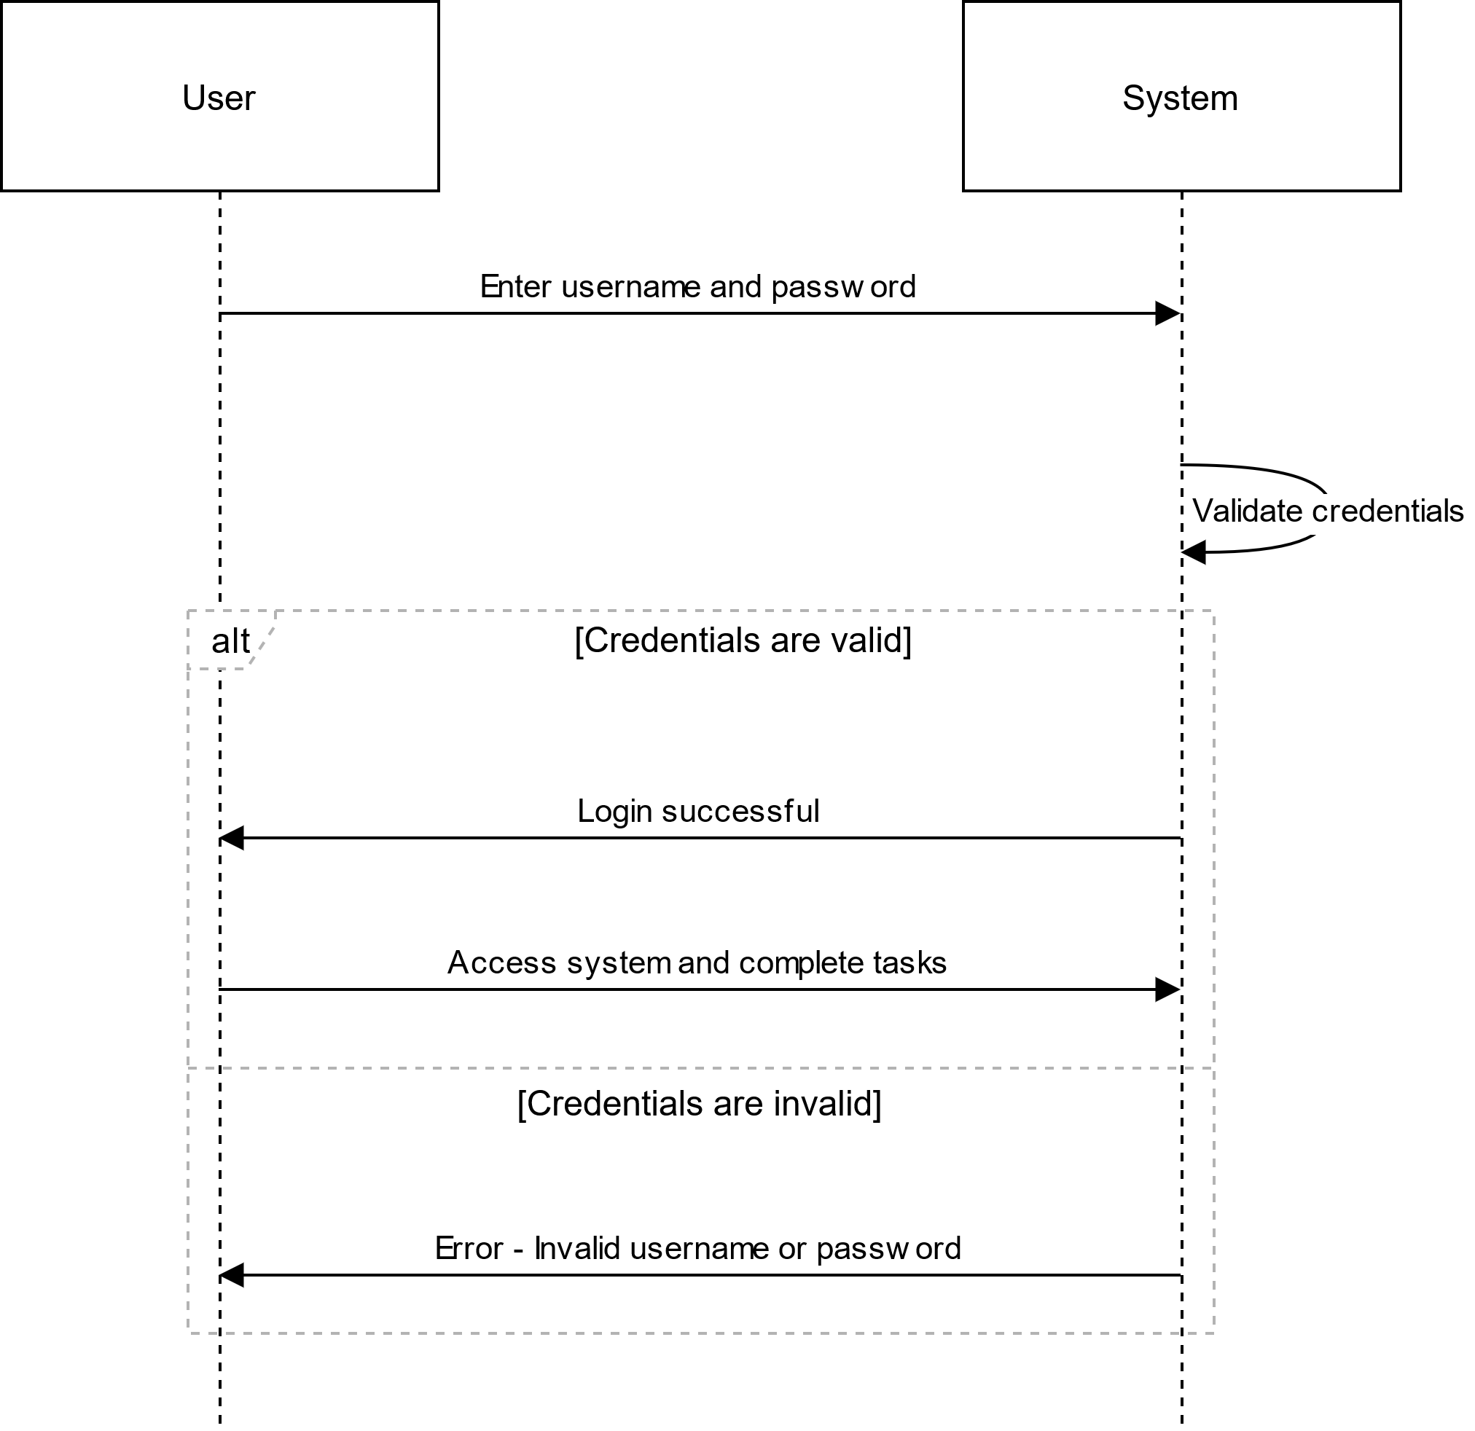

## RESET PASSWORD SSD

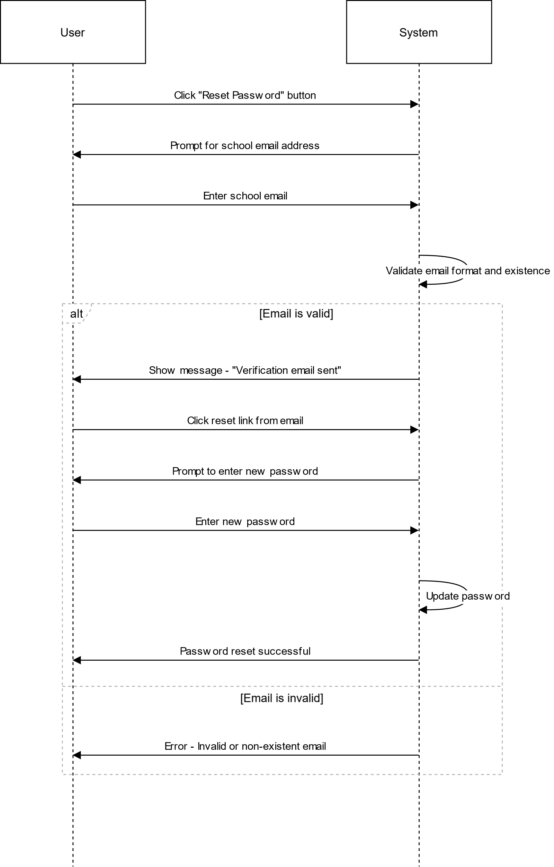

# US4

## CREATE ORDER SSD

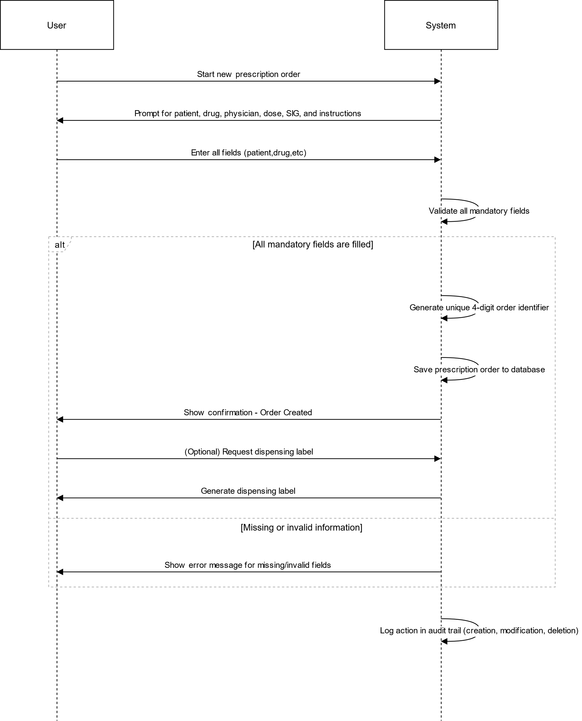

# US5

## IMAGE UPLOAD ON ADD ORDER PAGE

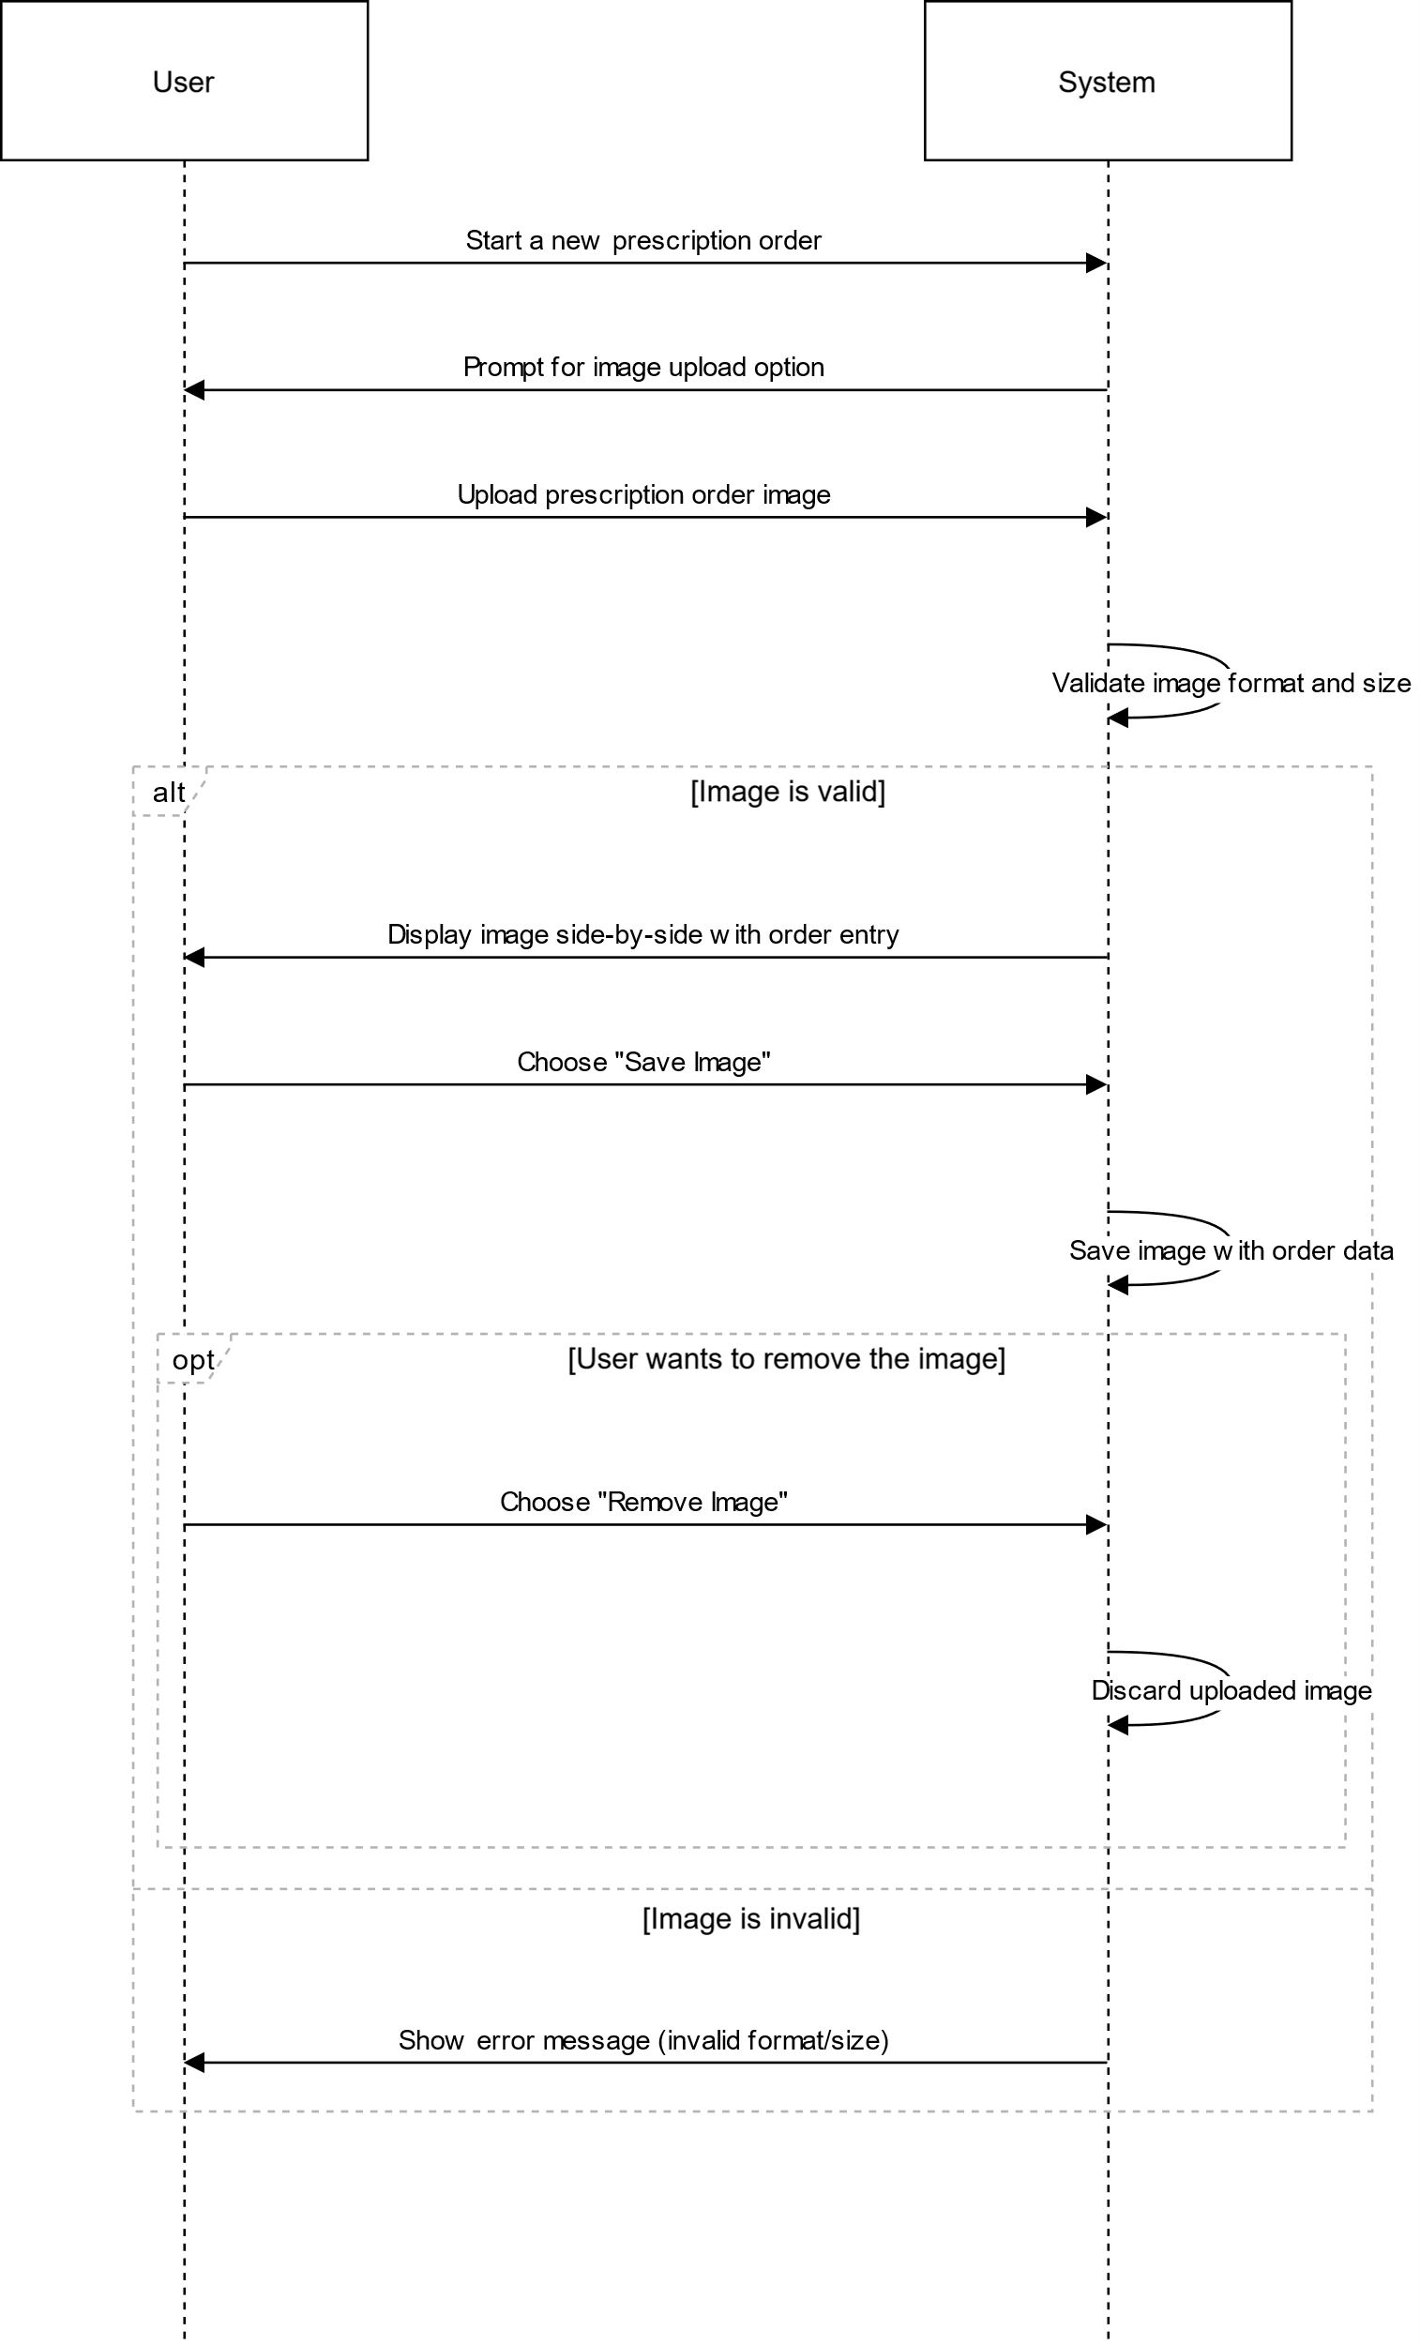

## IMAGE UPLOAD ON AMEND ORDER PAGE

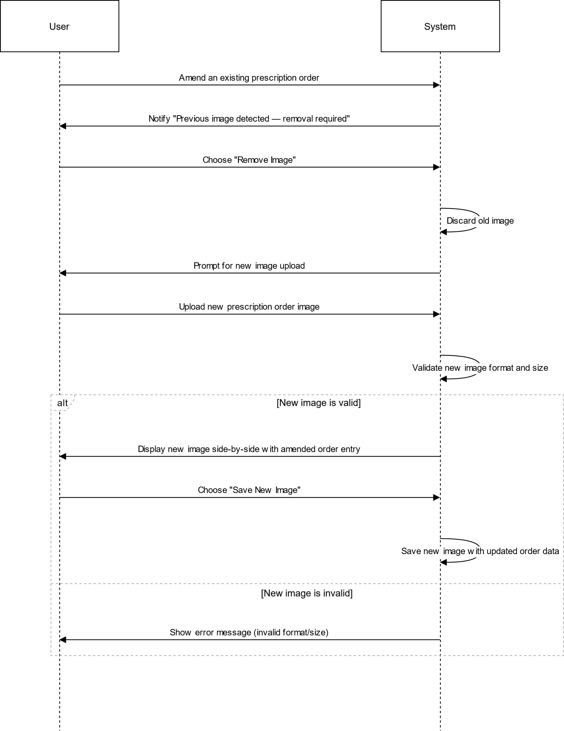

## IMAGE UPLOAD ON VERIFICATION PAGE

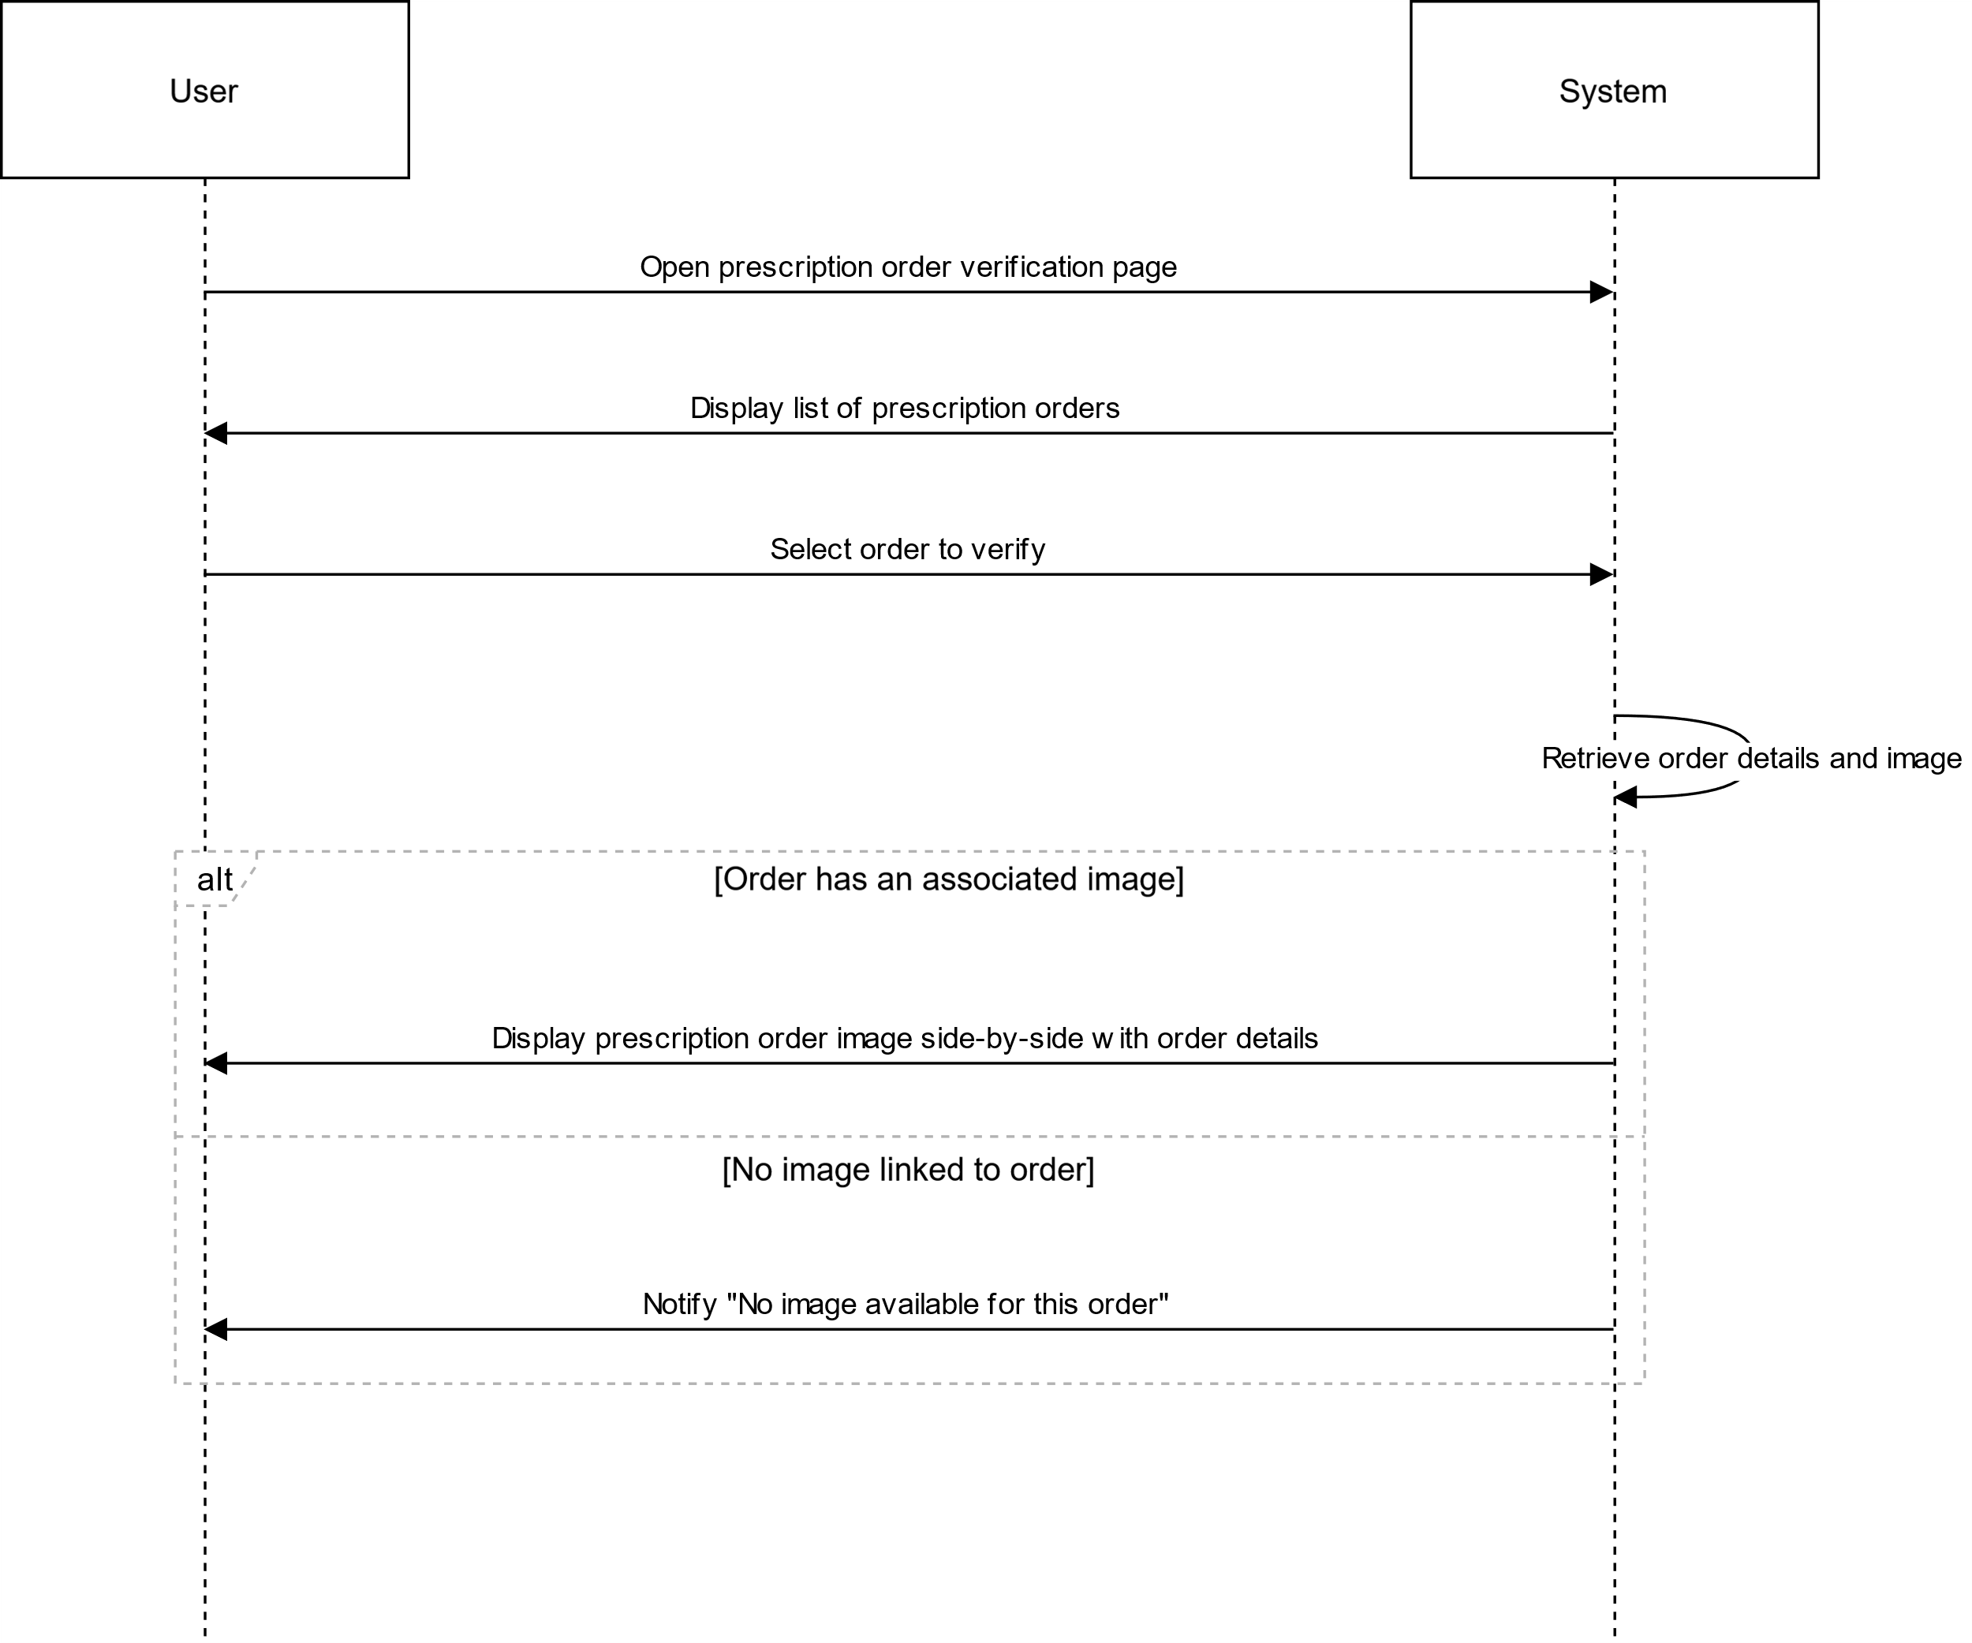

# US7

## VERIFY ORDER SSD

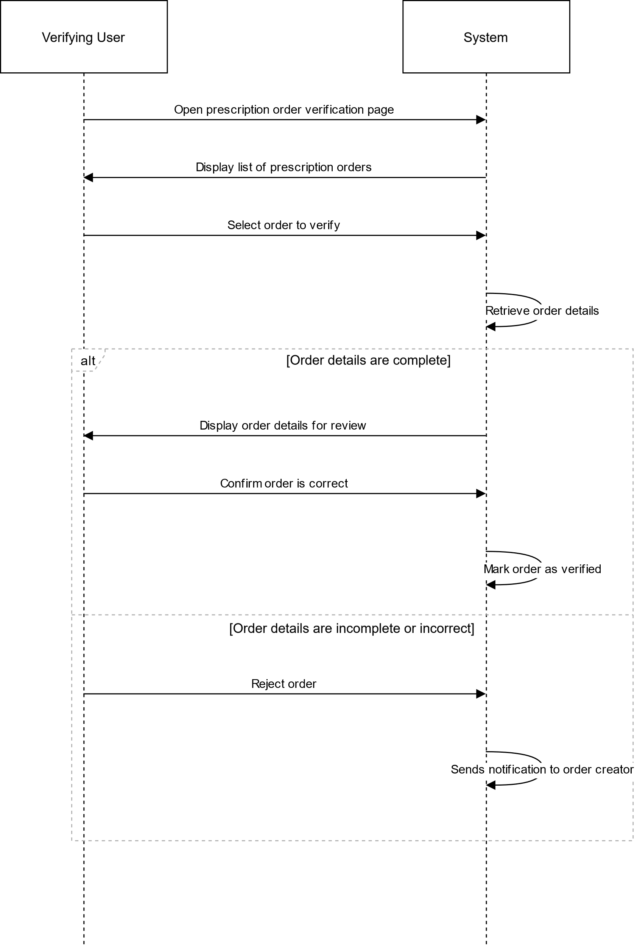

# US8

## AMEND ORDER

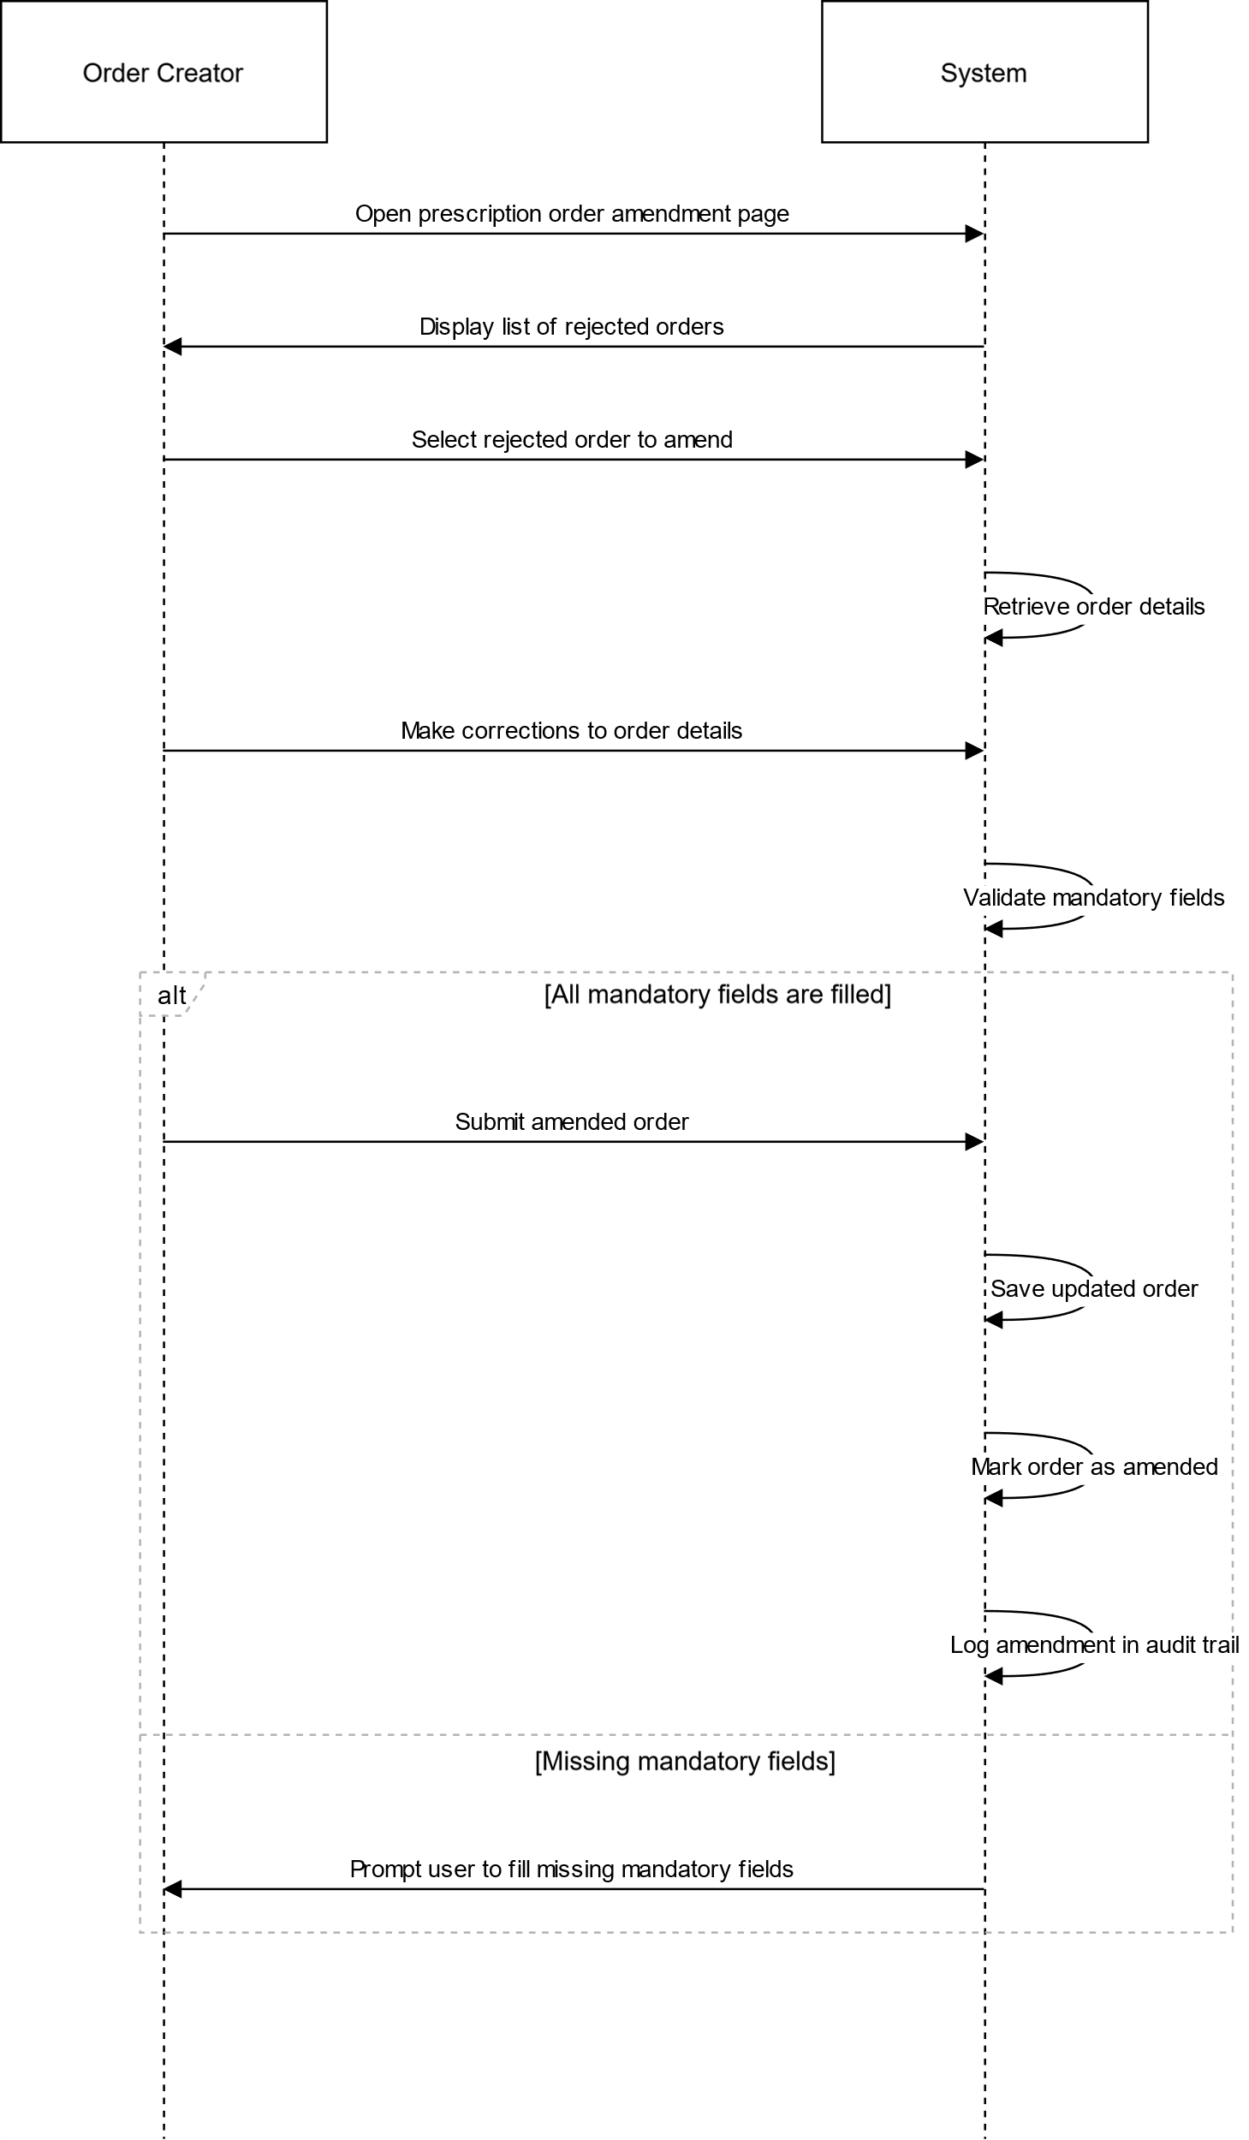

# US9

## PRINT DISPENSING LABEL SSD

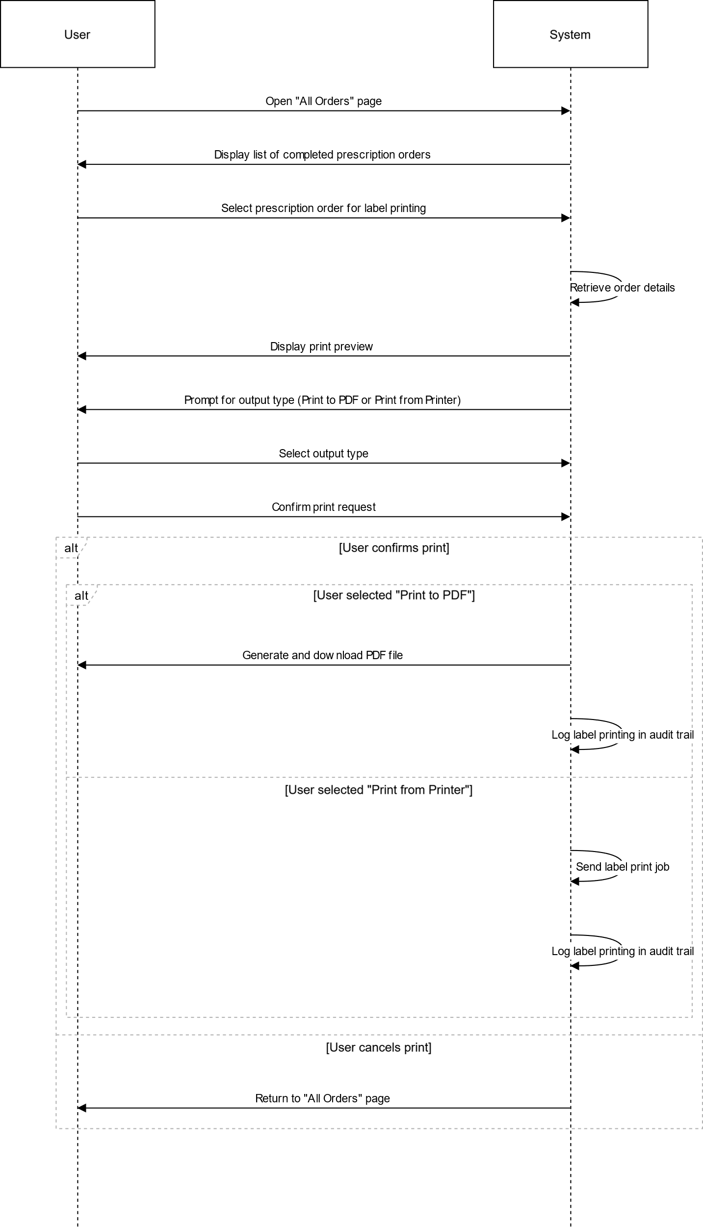

# US10

## RE-PRINT DISPENSING LABEL SSD

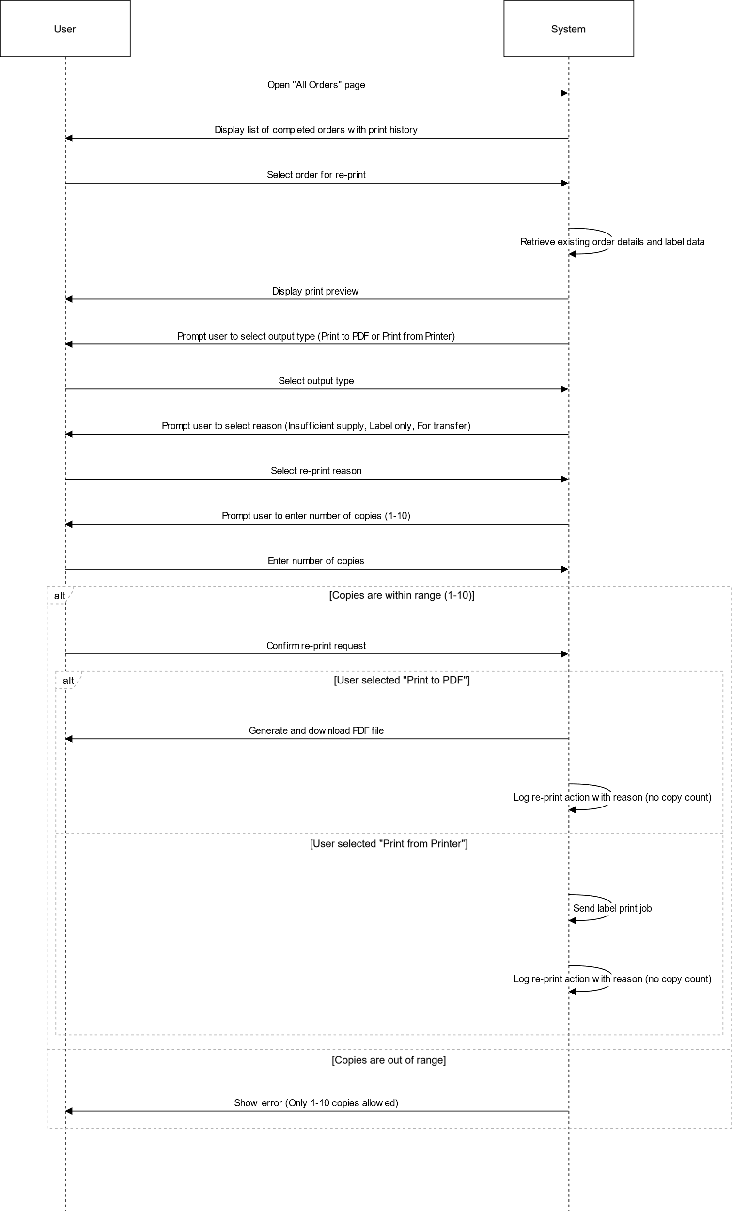

# US11

## INACTIVITY SSD

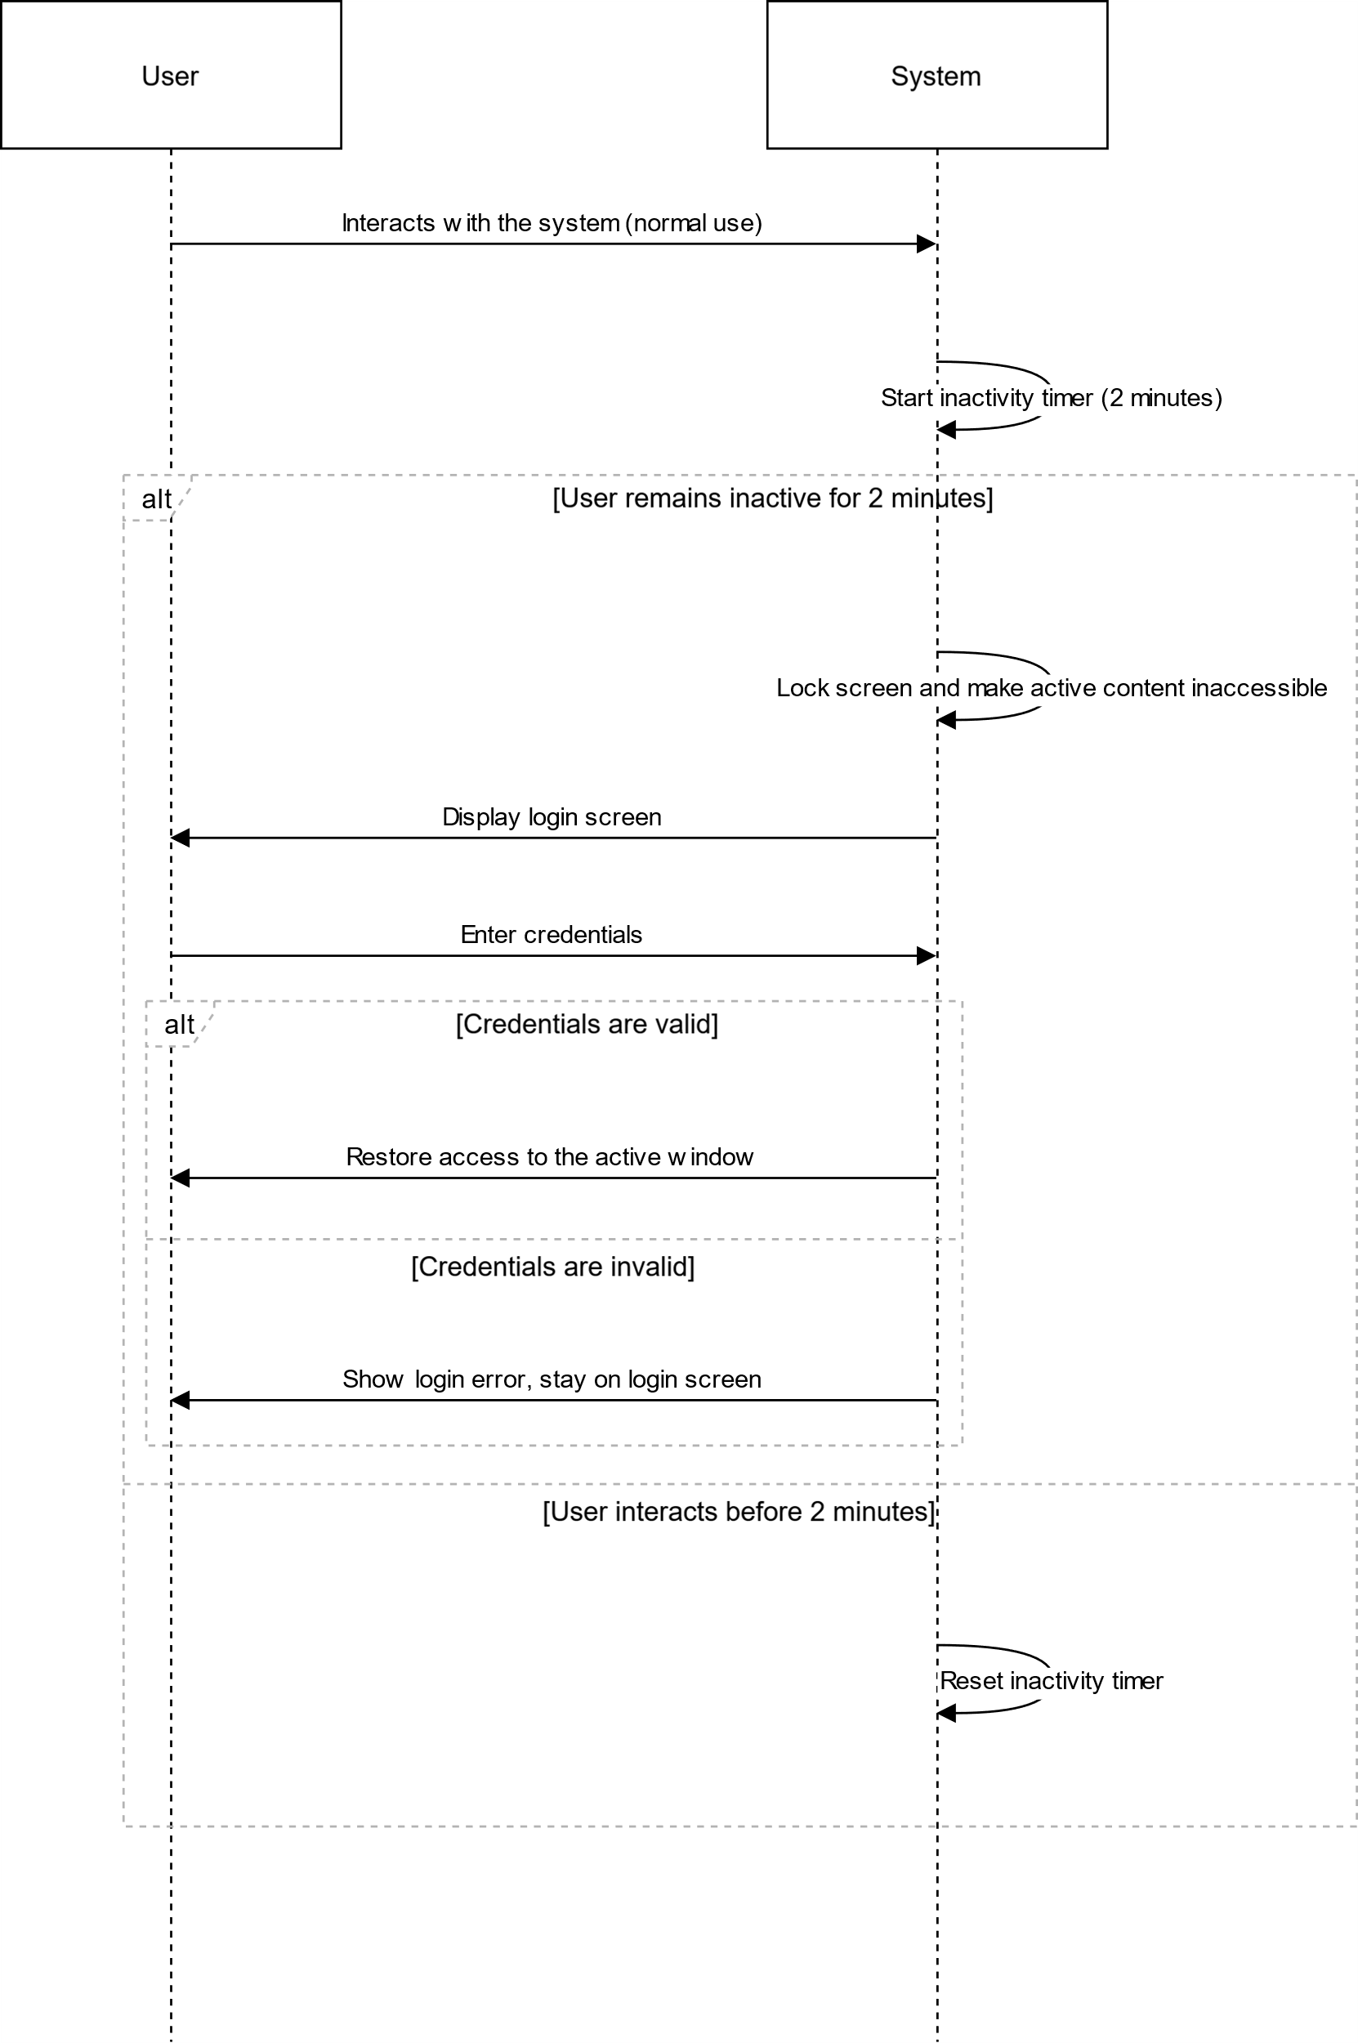

# US12

## VIEW ORDERS

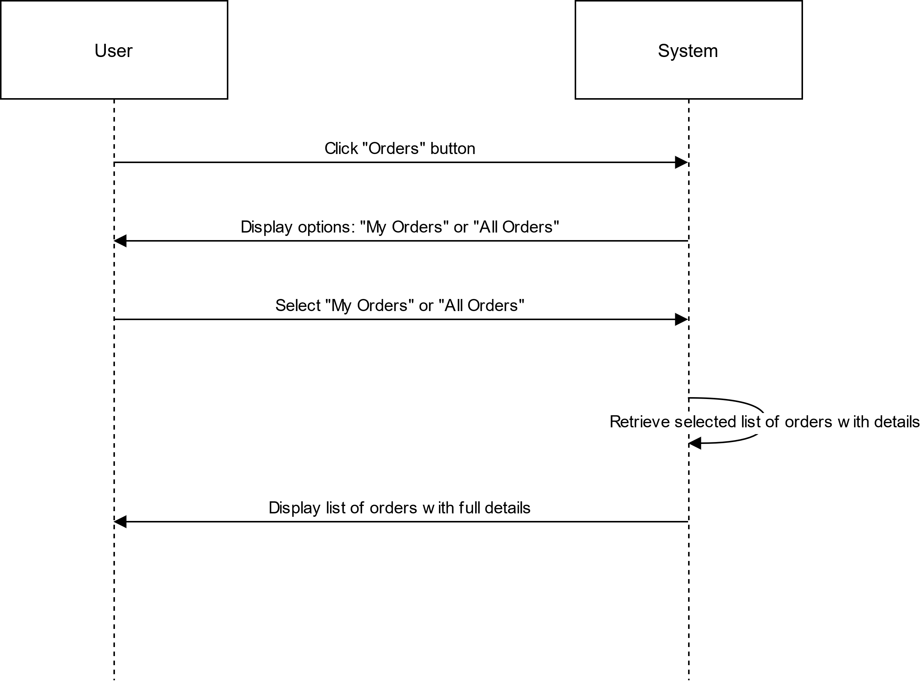

## ORDERS TO VERIFY

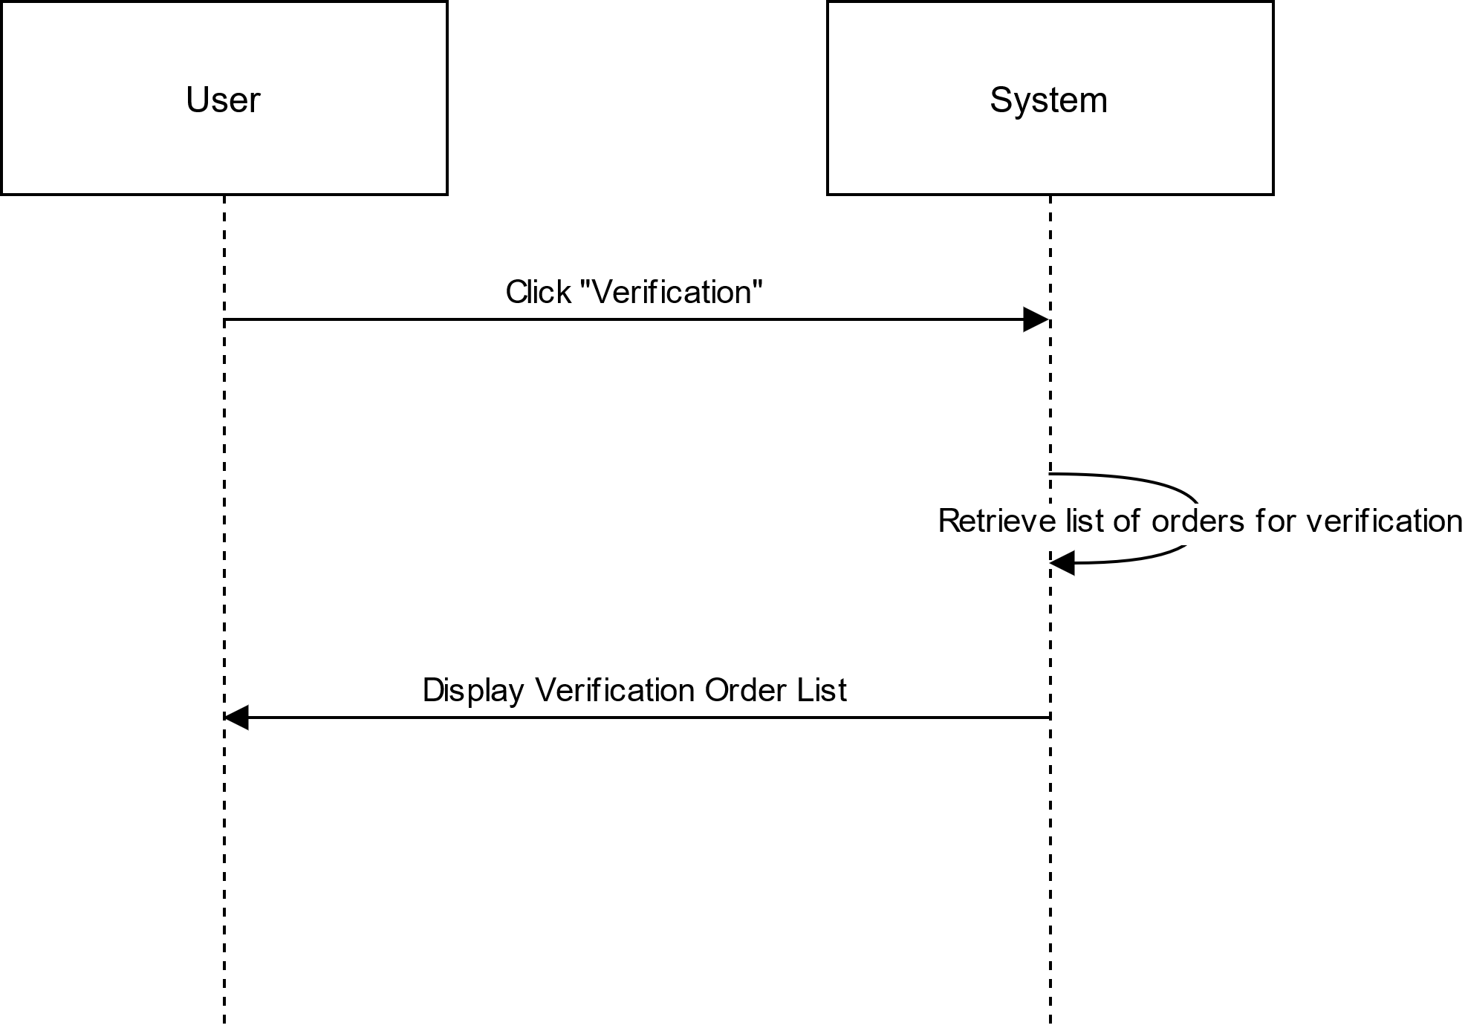

# US13

## ADD DRUG

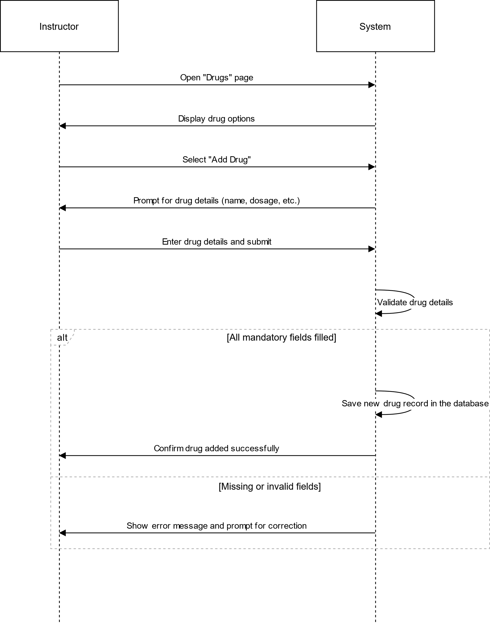

# US14

## VIEW DRUGS

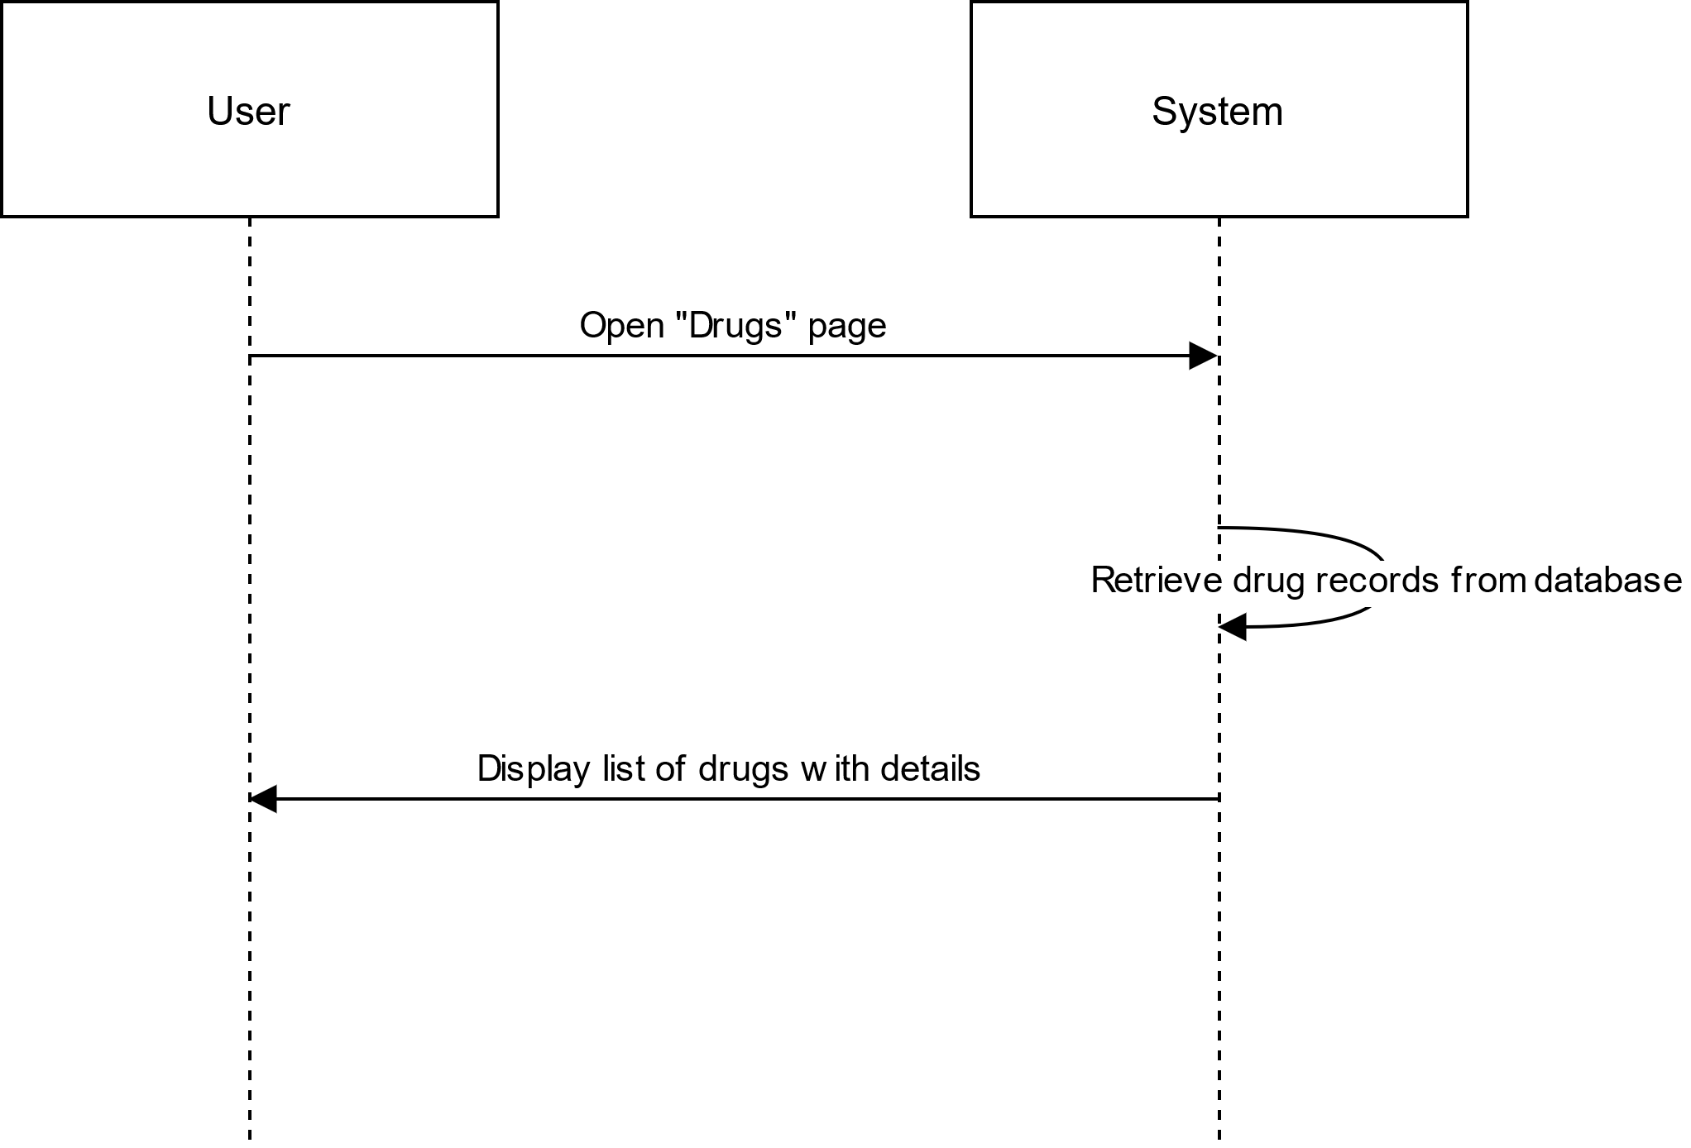

# US15

## DELETE DRUG(S)

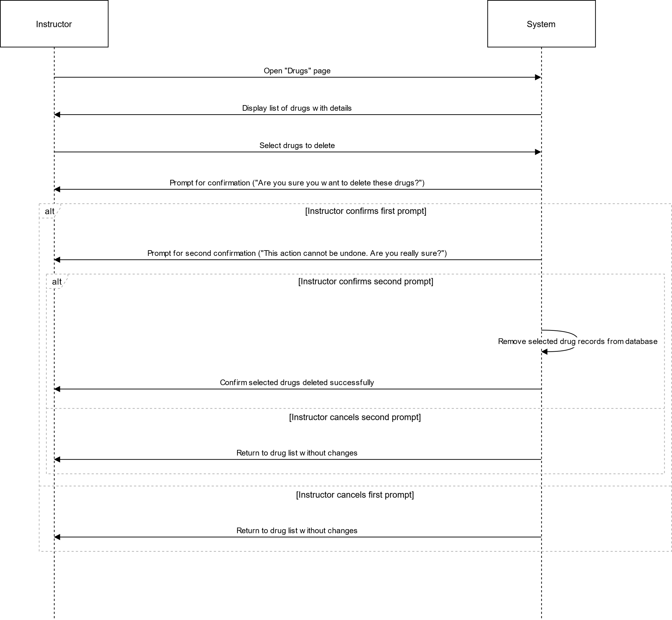

# US16

## EDIT DRUG

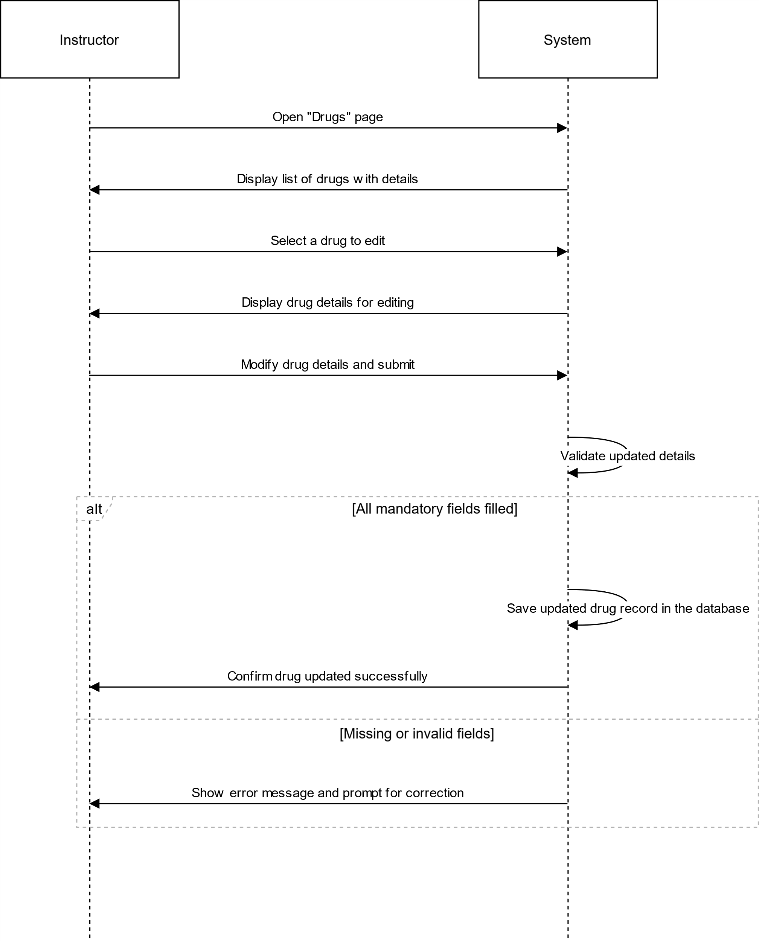

# US17

## ADD PHYSICIAN

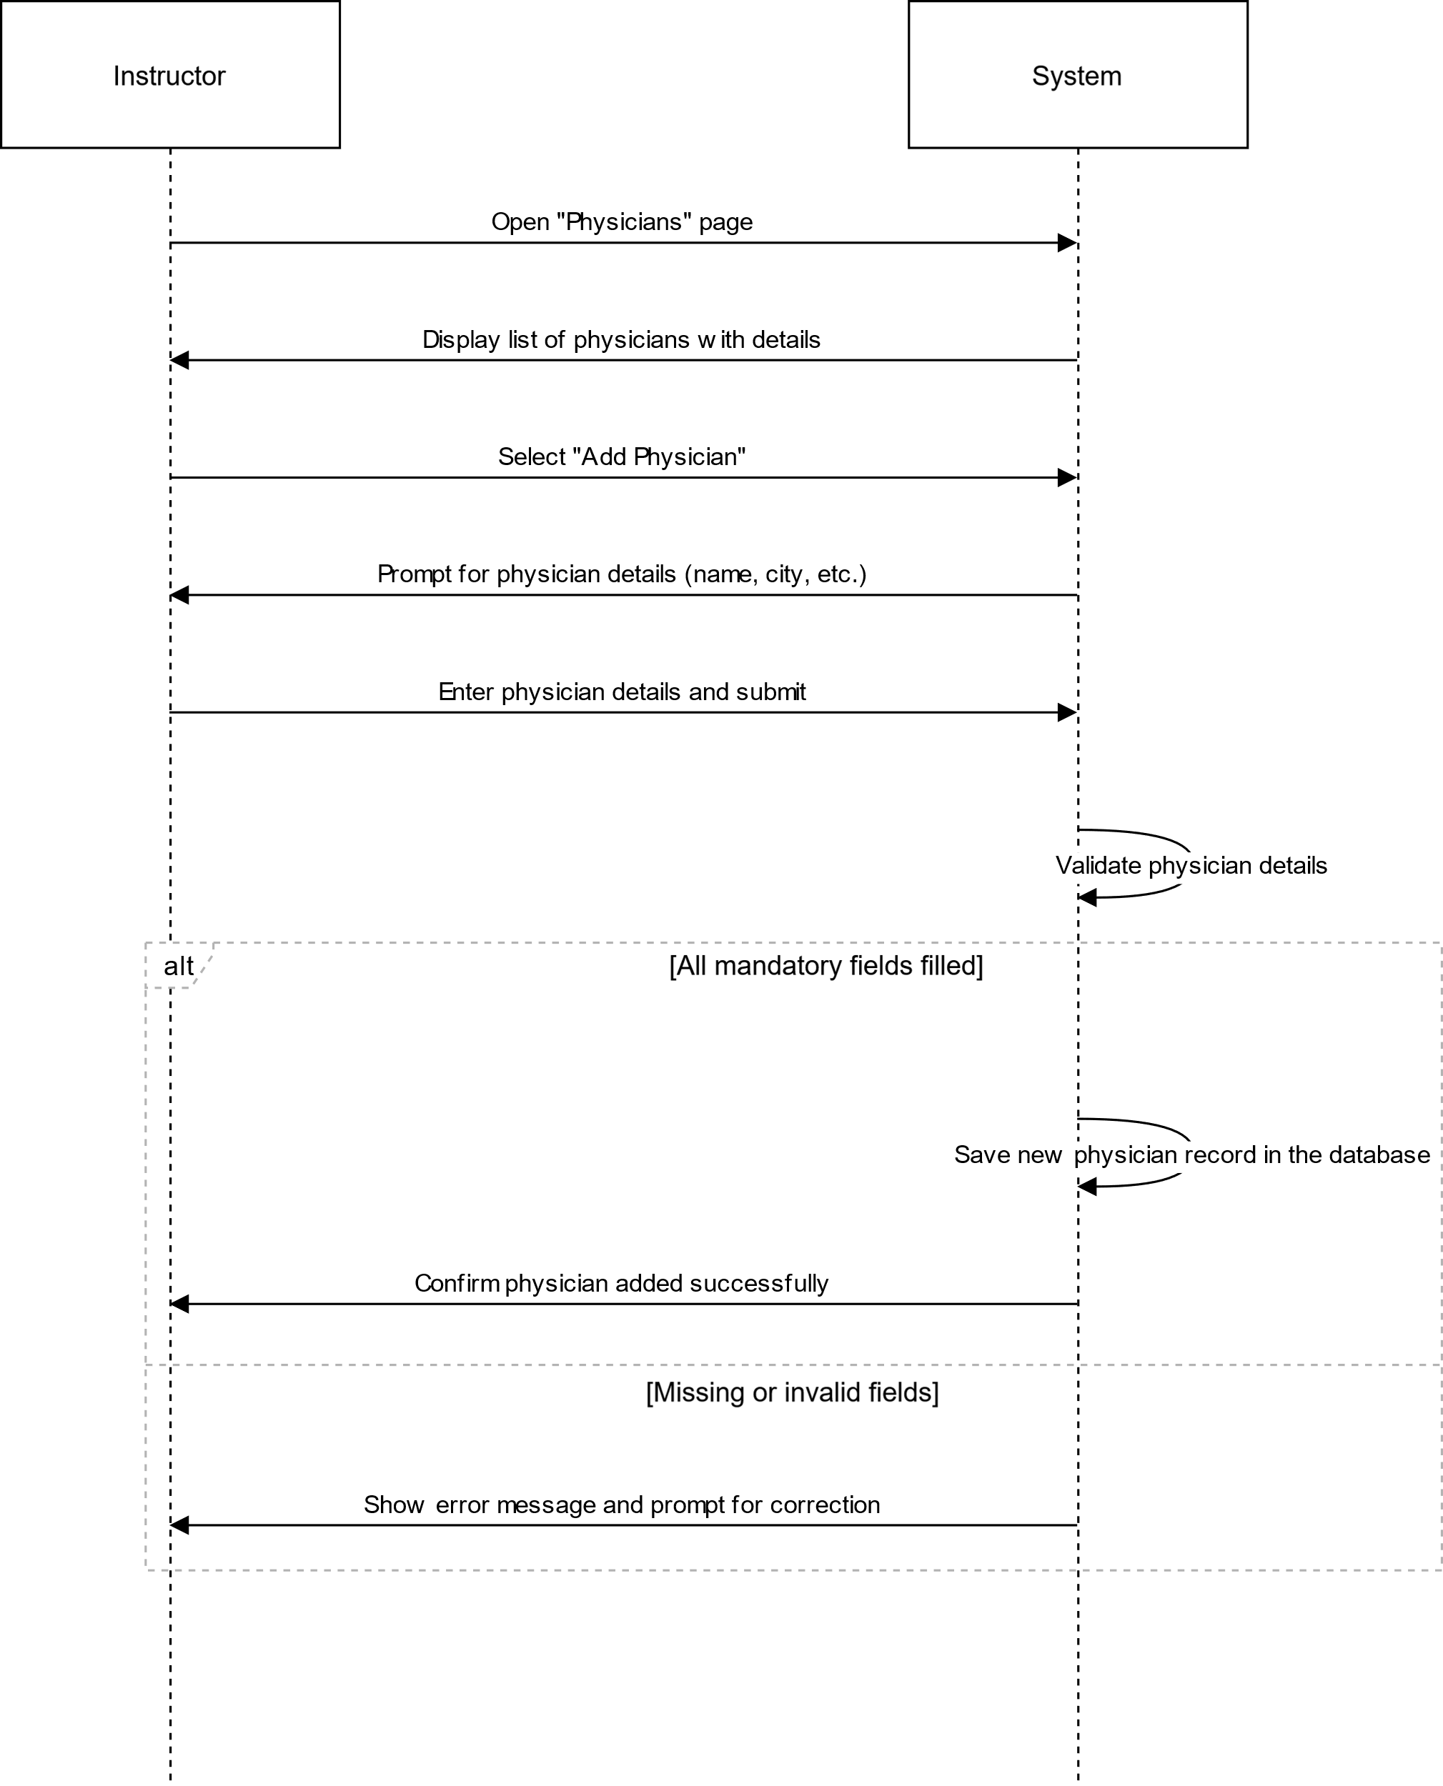

# US18

## VIEW PHYSICIANS

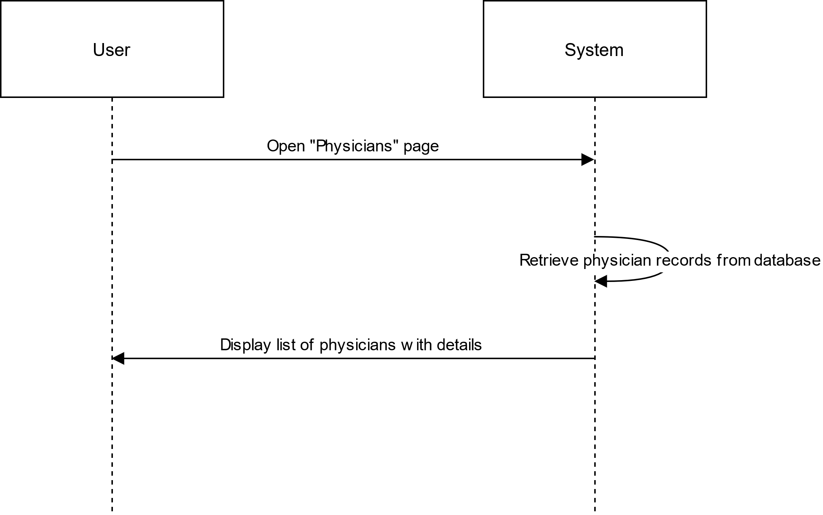

# US19

## DELETE PHYSICIAN(S)

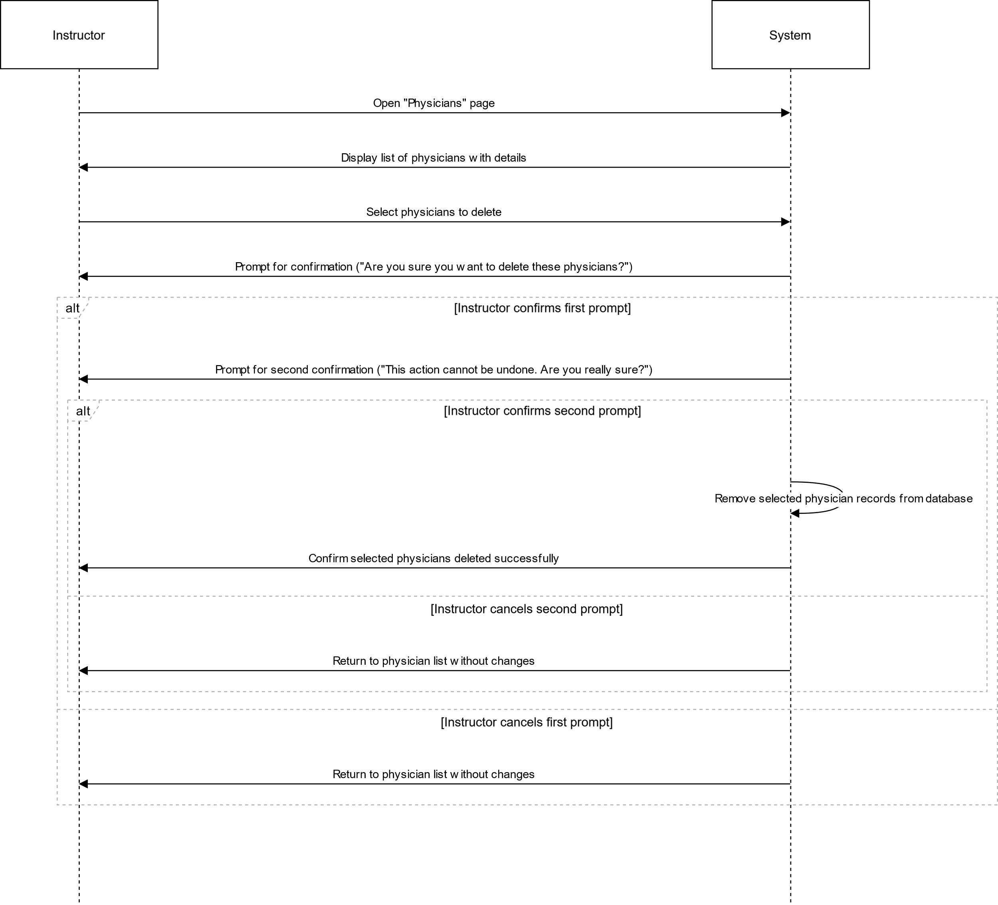

# US20

## EDIT PHYSICIAN

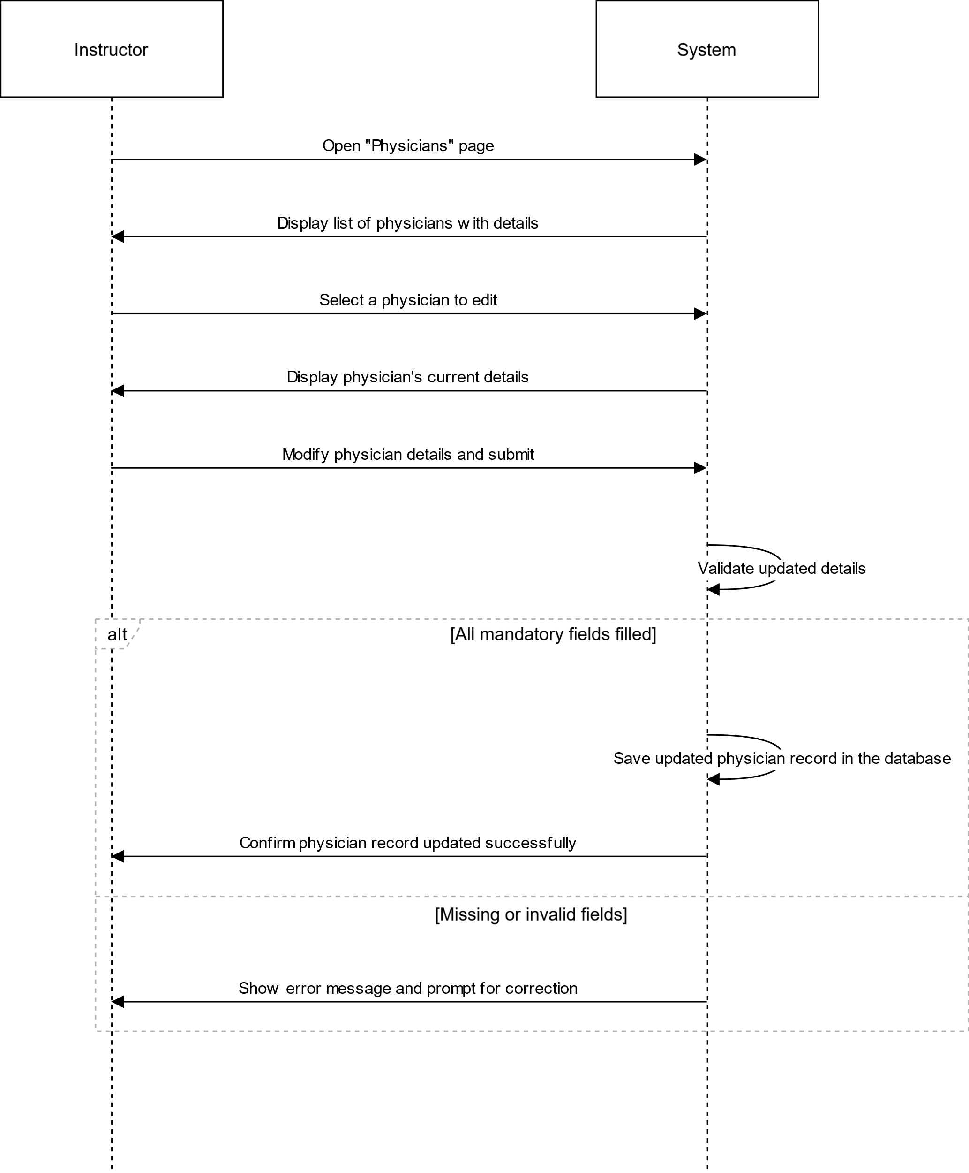

# US21

## ADD PATIENT

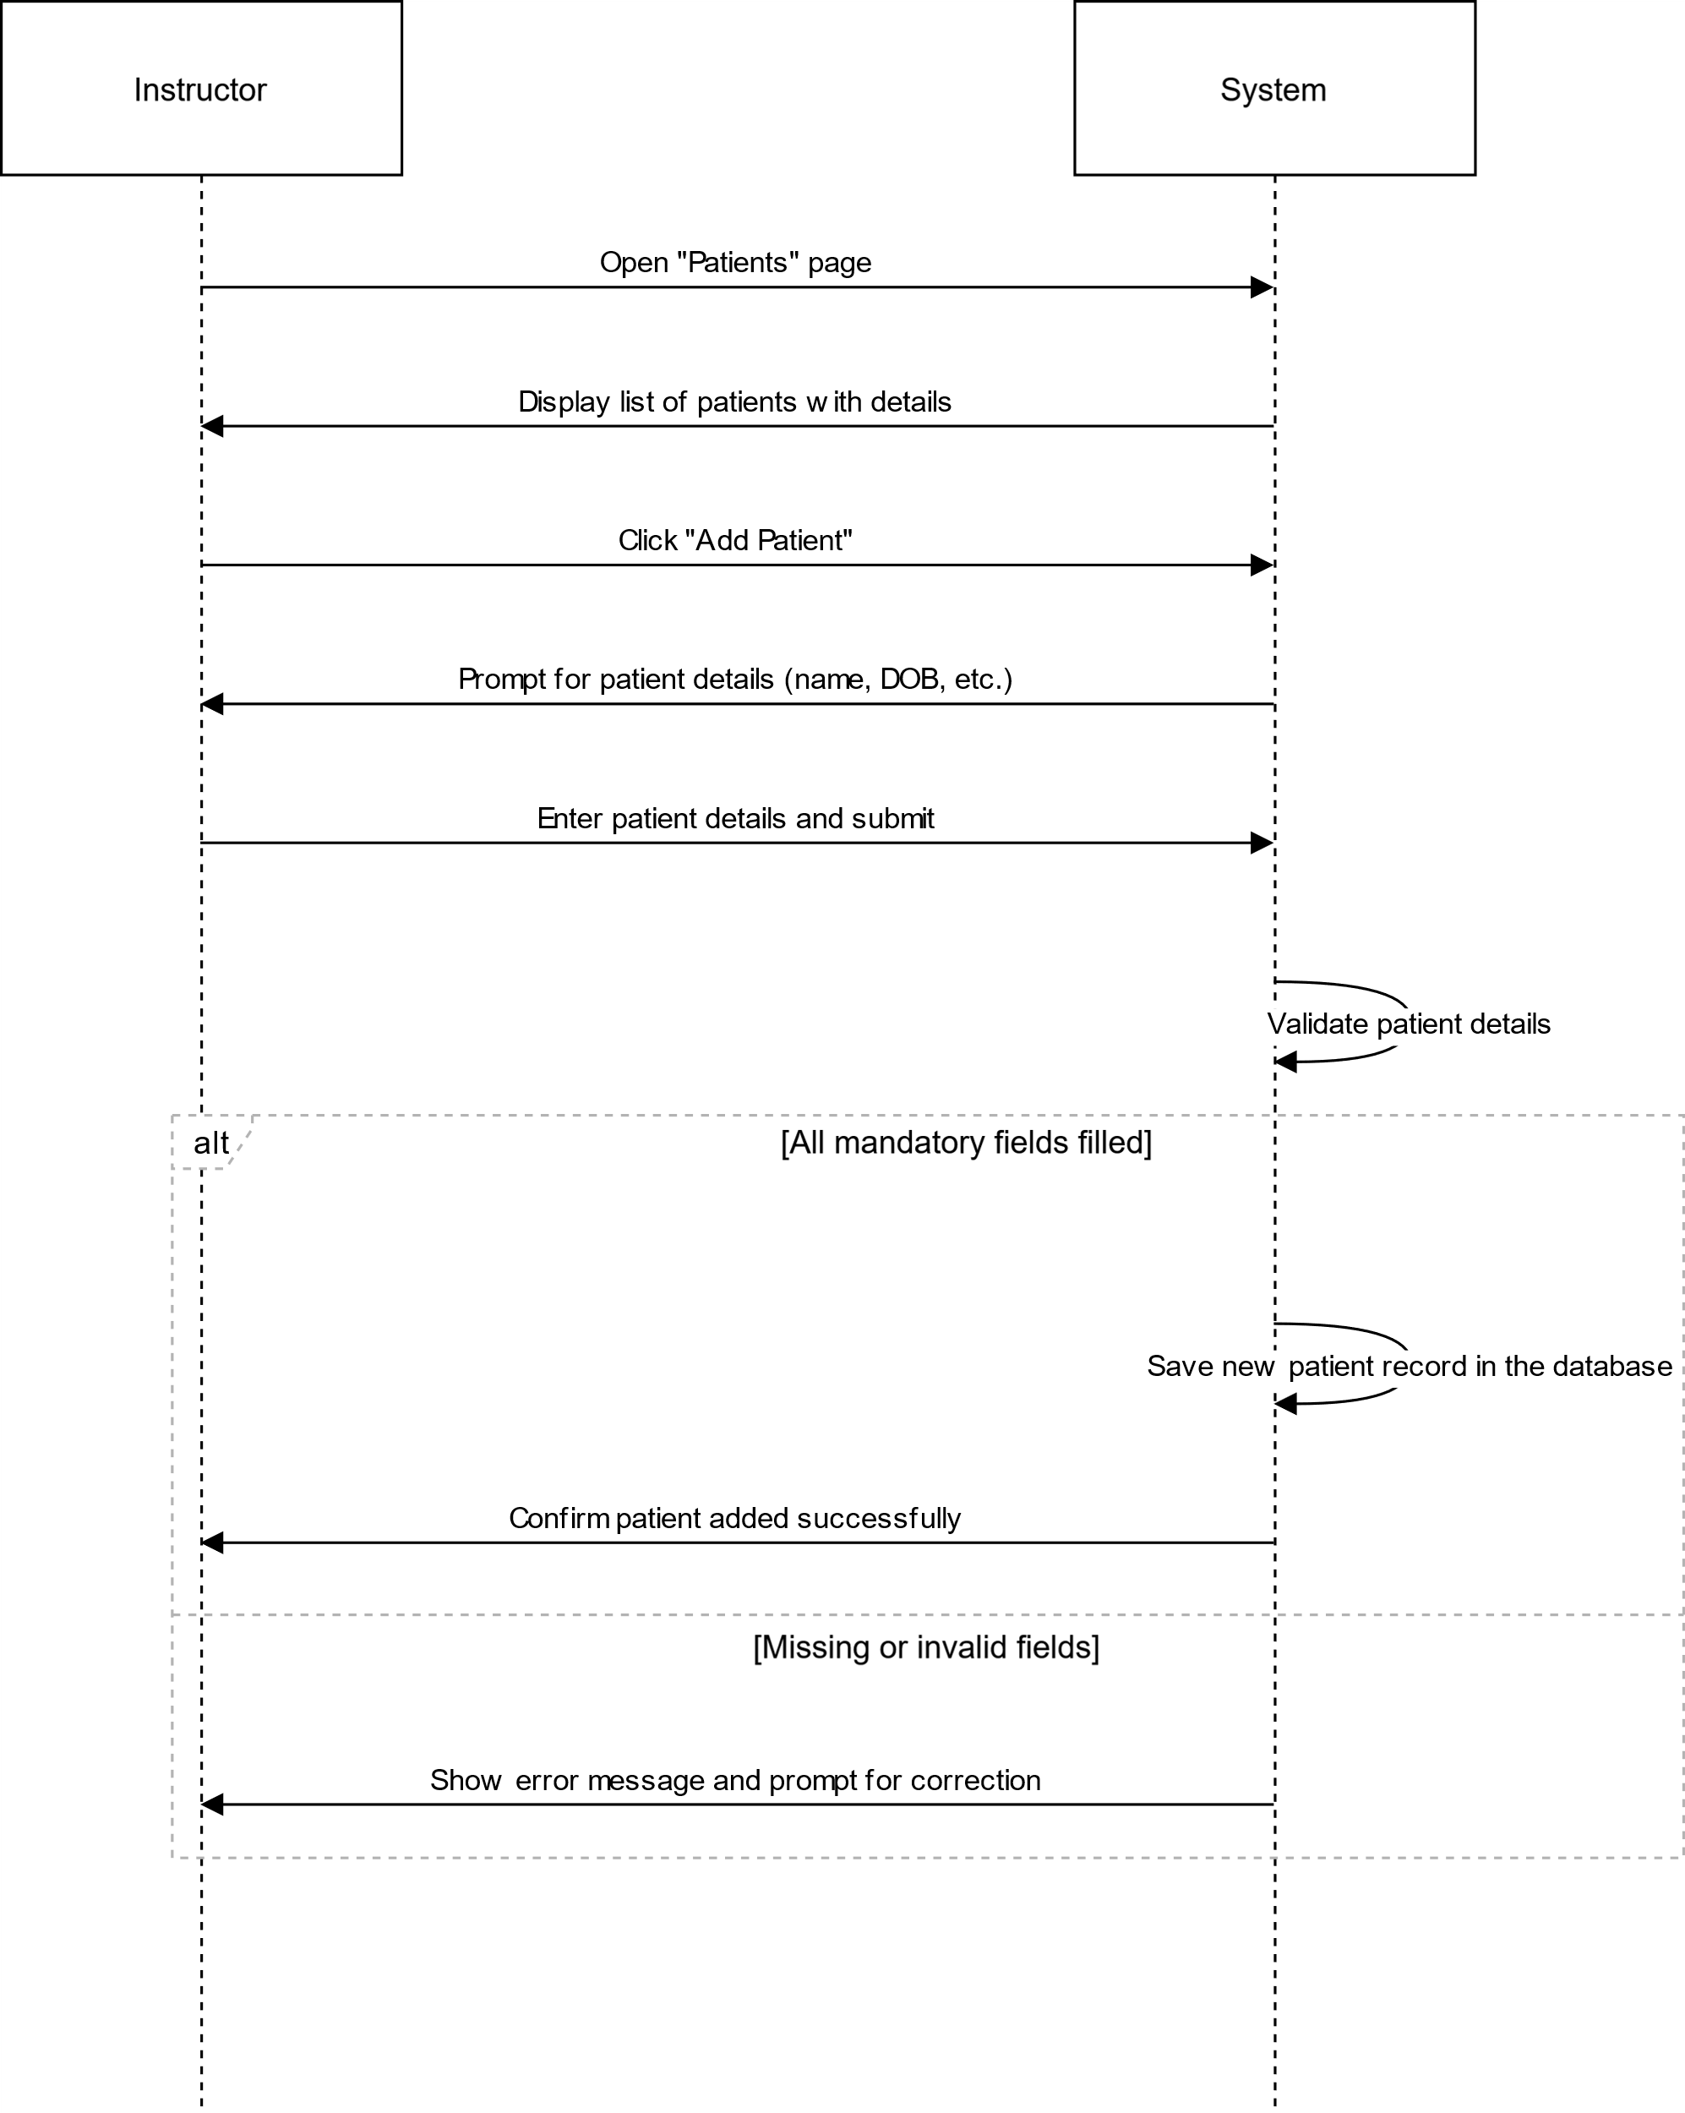

# US22

## VIEW PATIENTS

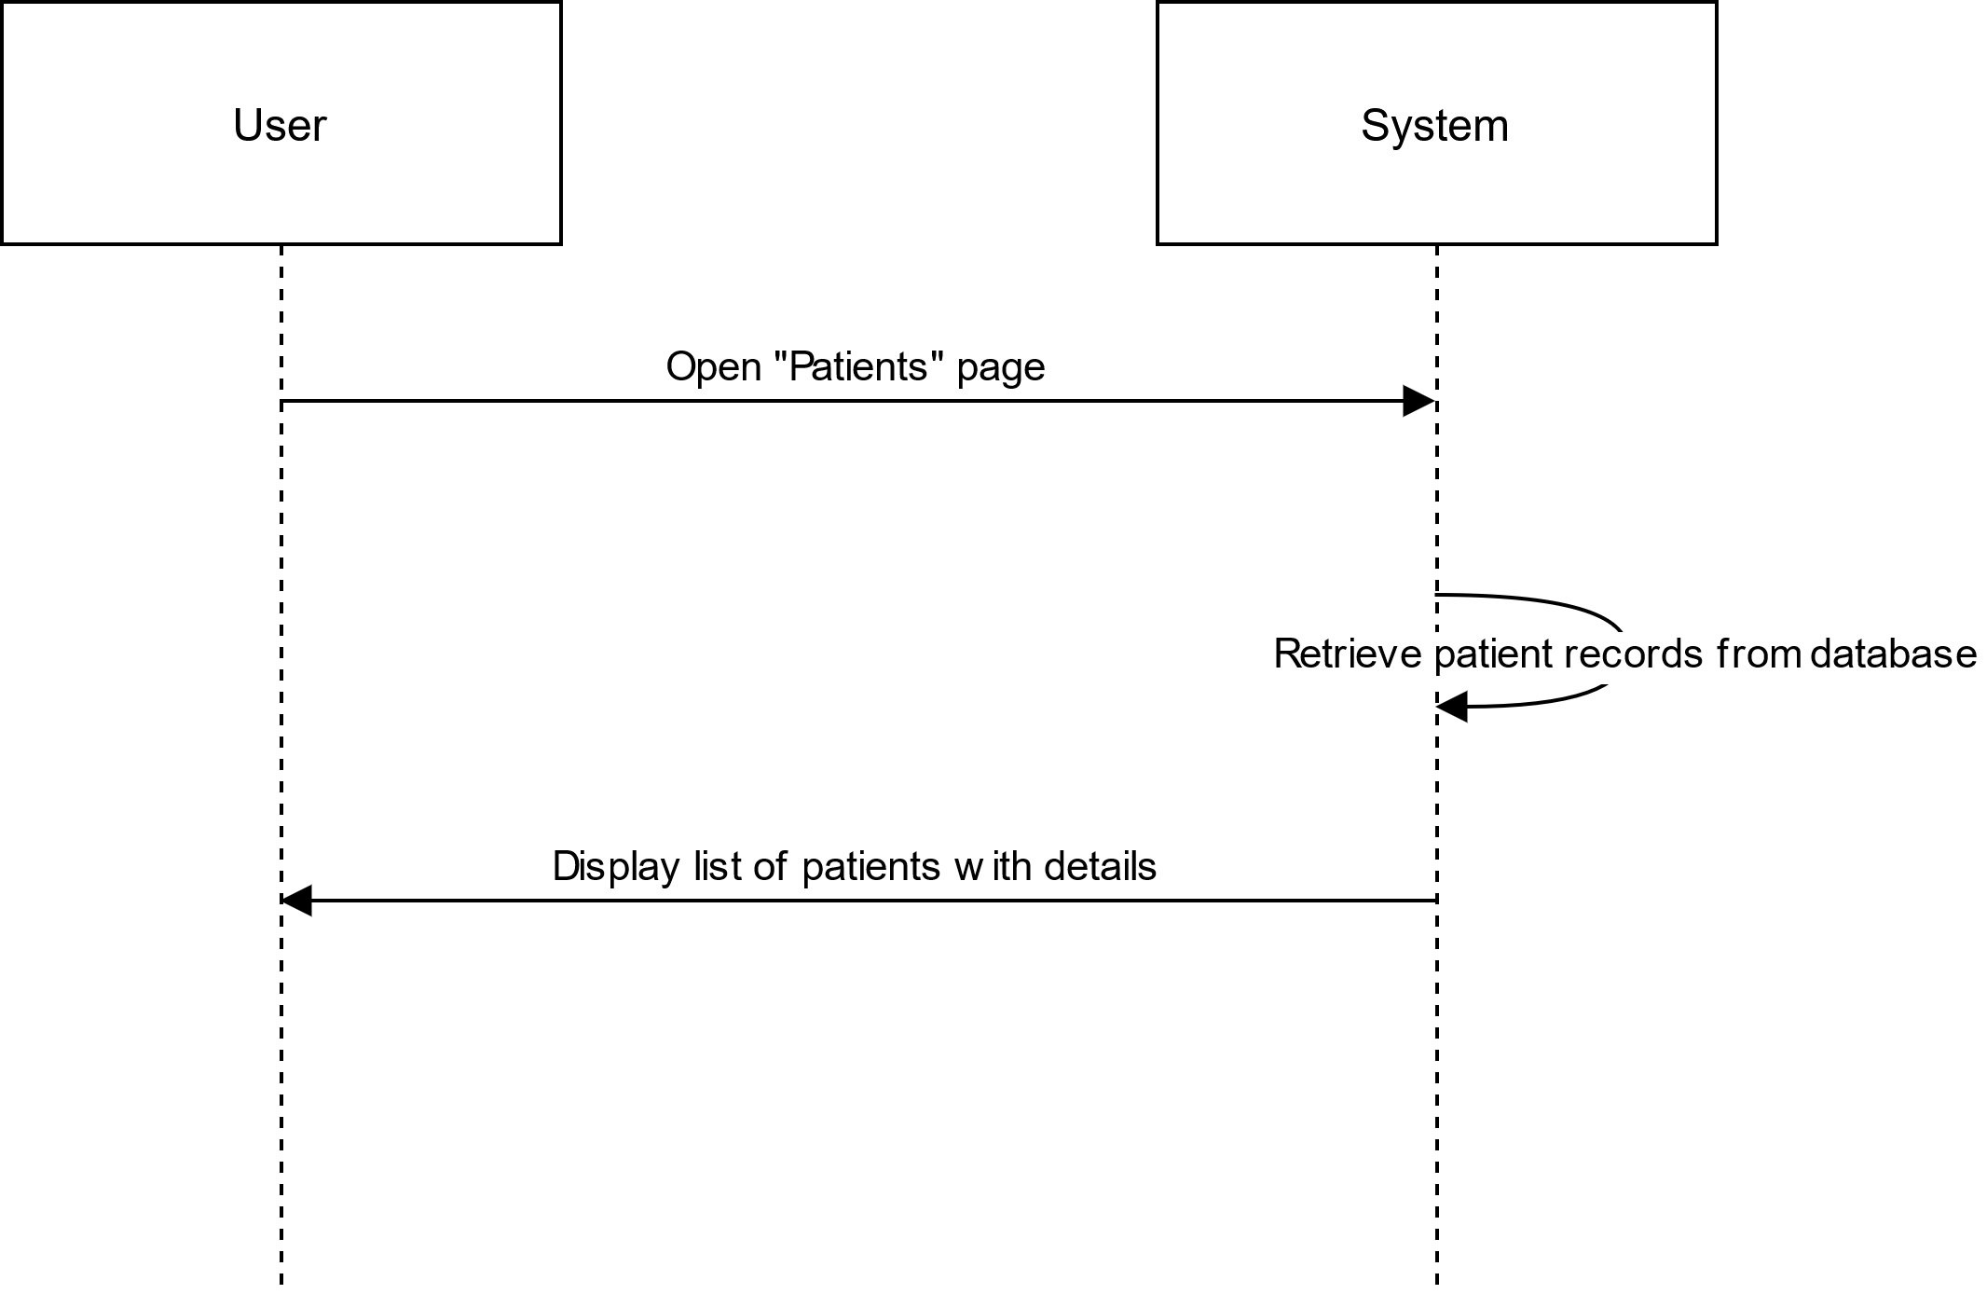

# US23

## DELETE PATIENT(S)

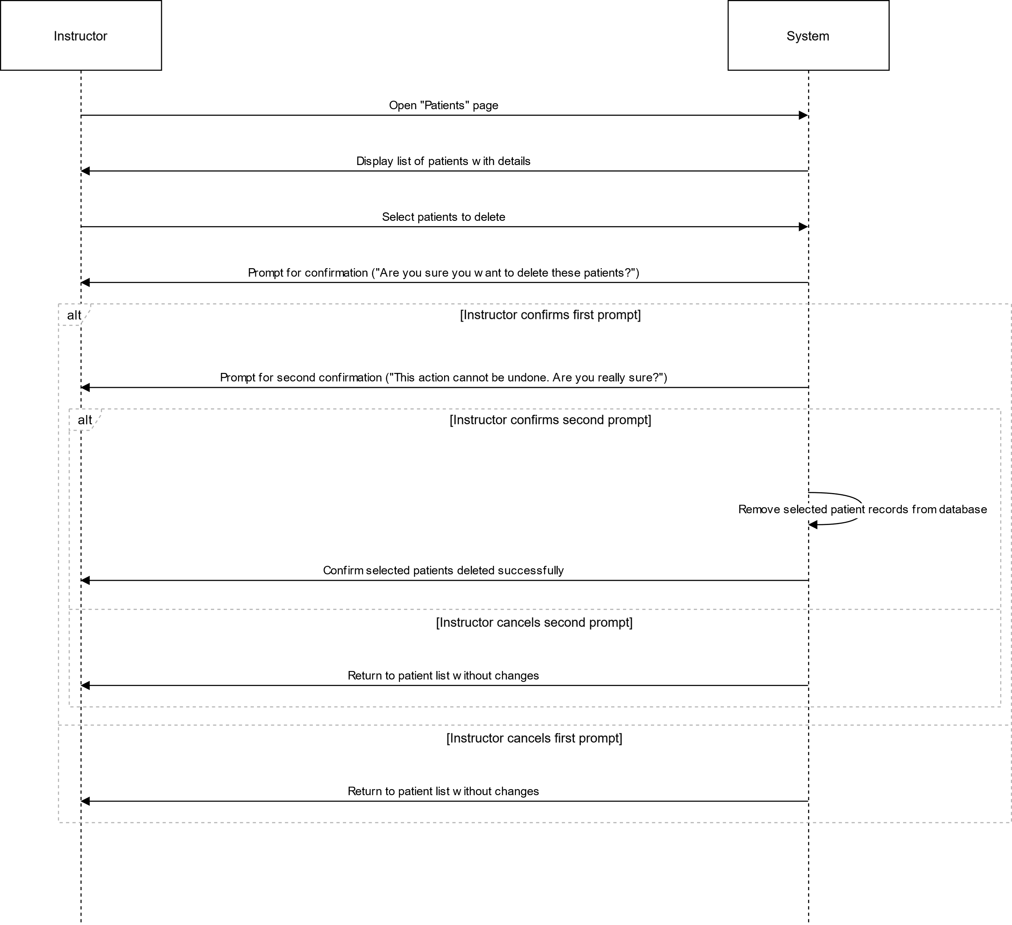

# US24

## EDIT PATIENT

